Learning About Bar Graphs

Graphs may look simple but they give us a great deal of information. The two types of graphs mainly used in science are the bar graph and the line graph. Although these types of graphs reflect different types of data, they both have the same features.
All graphs must have a descriptive title. NEVER title a graph GRAPH! The title must tell what the graph is about. A graph has an x and a y-axis. The horizontal line at the bottom of the graph is the x-axis and the vertical line on the side is the y-axis. They must have categories and/or numbers.
As you number each axis you must have equal intervals. Some times the difference can be as small as 1 and other times may be as large as 10,000. The interval can be any number but they must be equal.
Each axis must have a label to tell what the numbers represent. Typically you can use the labels in the data table to label your graph. The last feature that all graphs must have is a large scale. You should always make your graph as big as possible. You should never make a tiny graph. The scale of your graph should fill the graph paper as much as possible.

When we put all the features together we have an excellent graph. We can remember all these features using a memory helper called TAILS. Use the reading above to determine what each letter stands for.

T
A
I
L
S

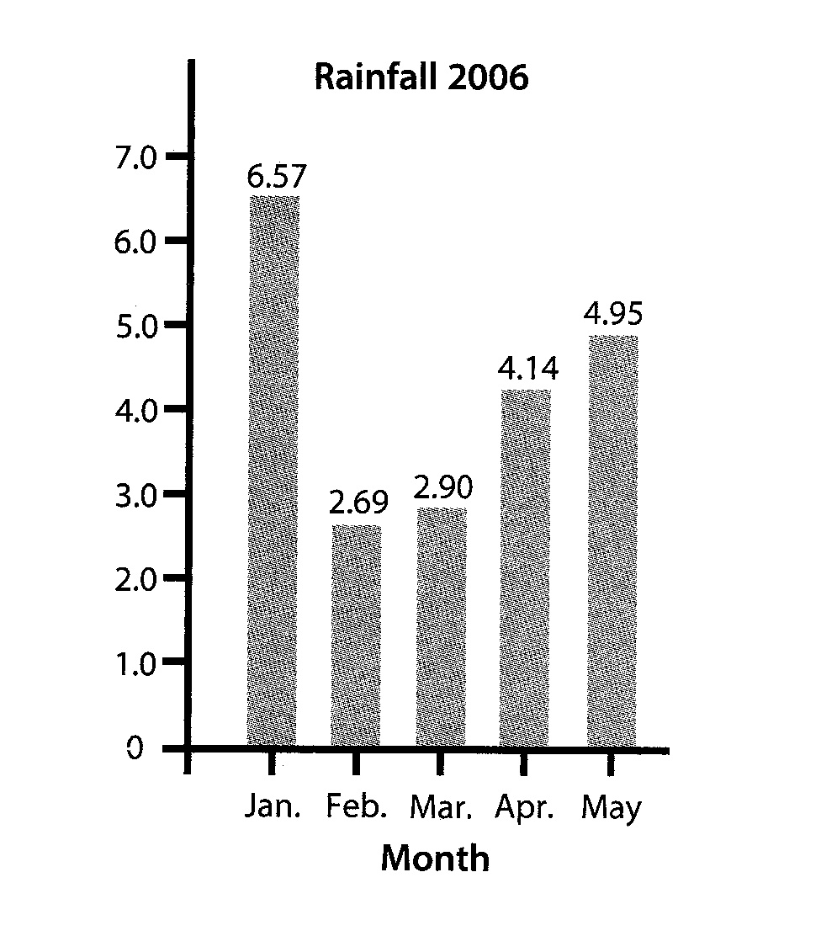

Answer the following questions about the graph.

1. Title __________________________________
2. Categories on the X-axis __________________
3. Numbers on the Y-axis ___________________
4. What is the interval along the X-axis? ________
5. What is the interval along the Y-axis? _______
6. What is the label on the X-axis? ____________
7. Does the graph fill the graph paper? ________
8. What is missing from the graph? _____________

Materials: Ruler
What To Do:
1. Use the ruler to measure the length of your fingers in centimeters.
WORD BANK
title x-axis y-axis
interval labels scale
2. Place the 0 end of the ruler on the line where your palm meets the finger.
3. Record your information below.
4. Make an excellent graph using TAILS.

Finger | Thumb | Pointer | Middle | Ring | Pinky
Length in cm.

Directions:
1. Use TAILS to label the graph below. Use the words in the WORD BANK.

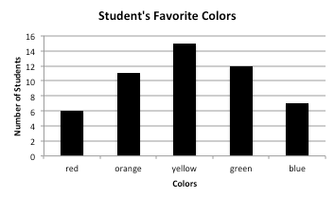

Name ______________ period _____

EXIT TICKET
Learning About Bar Graphs
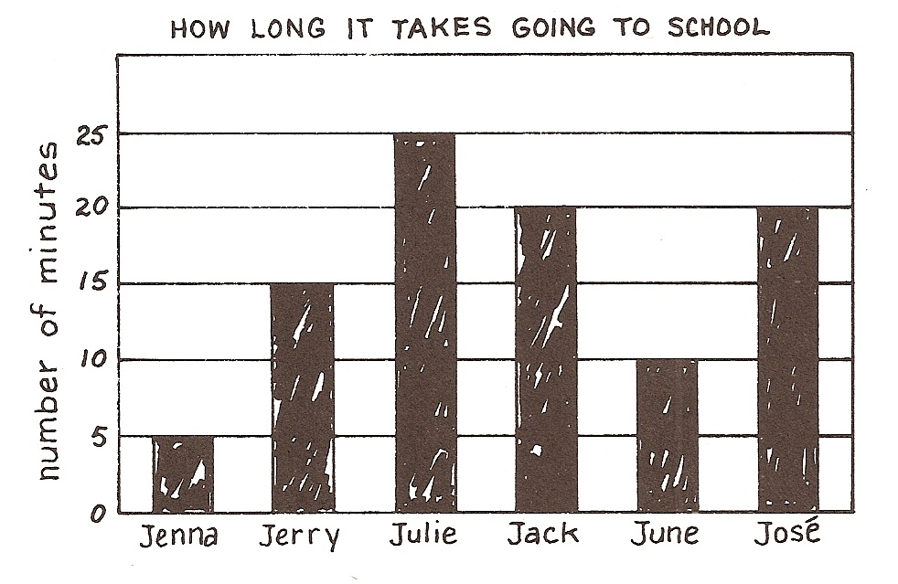

1. Title ________________________________

2. Interval on Y-axis ______________________

3. Label on Y-axis ________________________

4. Why is this graph not an excellent graph?

_________________________________________

Name ______________ period _____

EXIT TICKET
Learning About Bar Graphs

1. Title ________________________________

2. Interval on Y-axis ______________________

3. Label on Y-axis ________________________

4. Why is this graph not an excellent graph?

_________________________________________

