Learning About Line Graphs

In the last lesson you learned about how to use TAILS to make an excellent graph. We made a bar graph from the length of our fingers. The X-axis had categories and the Y-axis had numbers.
When a graph has numbers on both the X and Y-axis it is usually a line graph. Line graphs are able to show trends or patterns in the data. Trends can show whether the data is increasing, decreasing or staying the same.
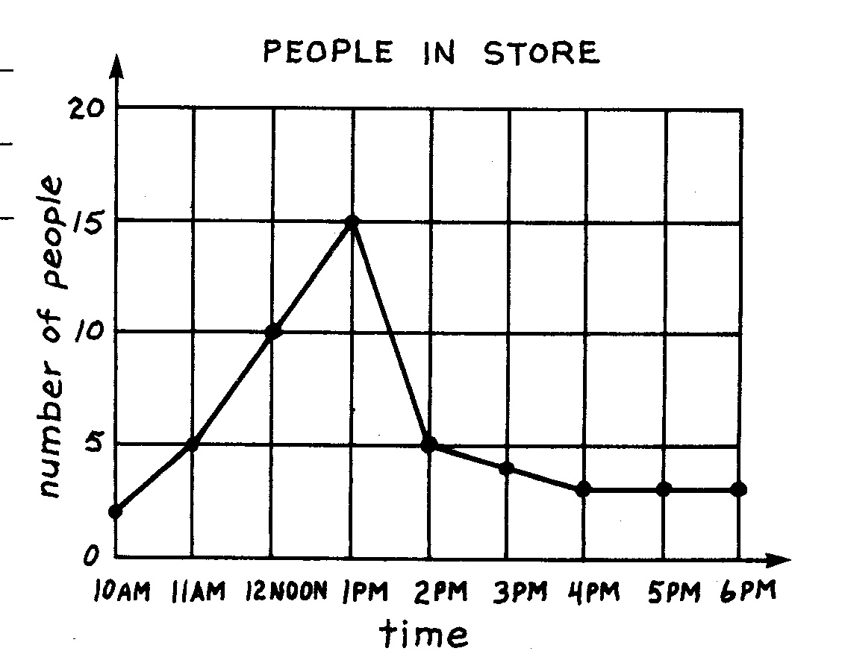

Questions:
1. What is the interval on the X-axis? _______
2. What is the label on the Y-axis? __________________
3. What is the trend between 10am and 1pm?
_______________________________________________
4. What is the trend between 1pm and 6pm?
_______________________________________________

Sometimes data is compared on a line graph by having a double line graph. You can then compare trends between sets of data.
On a double line graph it is important that you have a key to show what each line represents.
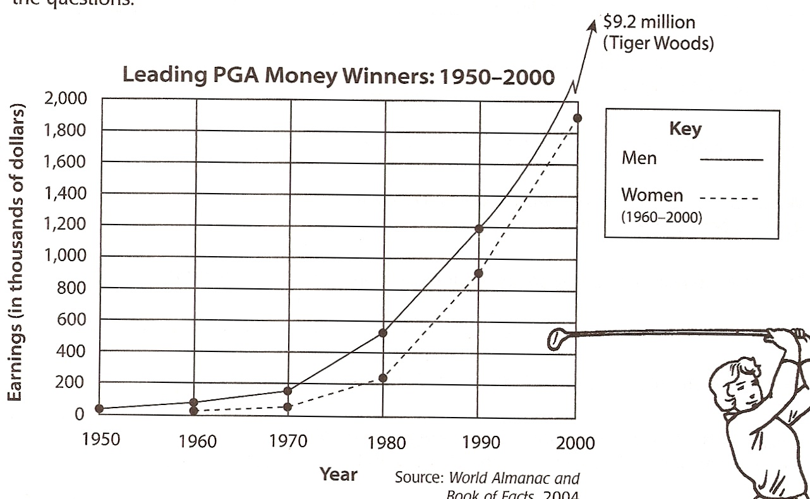
Questions:
1. What is the interval on the Y-axis? __________
2. What data is this graph comparing?
_________________________________________
3. What is the trend for men golfers? ___________
4. What is the trend for women golfers? _________
5. Why do you think there is no line for women golfers from 1950-1960? ____________________

What To Do:
1. Make an excellent graph using TAILS from the data below.

People in a Store
Time | 10 am | 11 am | 12 pm | 1 pm | 2 pm | 3 pm | 4 pm | 5 pm | 6 pm
Number of People | 2 | 5 | 10 | 22 | 15 | 5 | 4 | 4 | 3

What To Do:
1. Make an excellent graph using TAILS from the data below.
2. Make each line a different color. Fill in the key.
Time in seconds | Baby Sarah  Distance in meters | Baby Scott  Distance in meters
0 | 0 | 0
2 | 1 | 1
4 | 1.5 | 2
6 | 2 | 2.5
8 | 2.5 | 3
10 | 3 | 3.5

Baby
Sarah

Baby
Scott

Name ______________ period _____
EXIT TICKET
Learning about Line Graphs
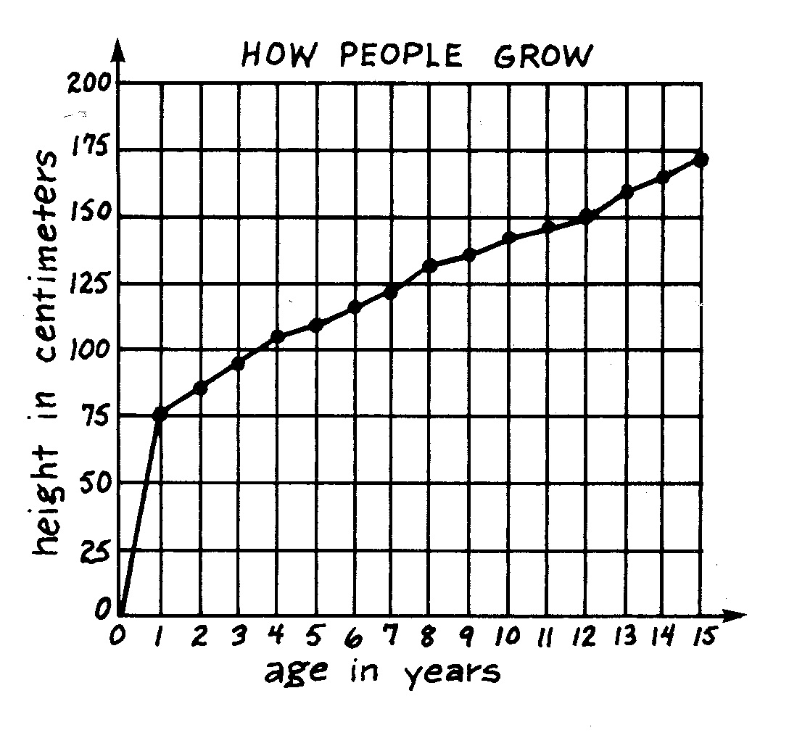

1. What is the trend from year 0 to year 15?
_______________________________________
2. What is the interval on the Y-axis? _________
3. What is the label on the X-axis? _____________
4. What is the title? __________________________

Name ______________ period _____
EXIT TICKET
Learning about Line Graphs

1. What is the trend from year 0 to year 15?
_______________________________________
2. What is the interval on the Y-axis? _________
3. What is the label on the X-axis? _____________
4. What is the title? __________________________

