Finding the Volume of

Irregular Objects
We have been learning how to measure length, mass, temperature and volume. We have learned that we can measure the volume of a liquid with a graduated cylinder.
Remember that volume is the amount of space an object or liquid takes up. In math class you have probably found the volume of a regular solid by multiplying its length x width x height. But what happens if a solid is irregular?
We can find the volume of an irregular object by placing it in water and measuring the difference in volume. This is called water displacement. Think about when you sit in a bathtub. You are displacing the water, so it goes up the sides of the bathtub. The same thing happens in the graduated cylinder.

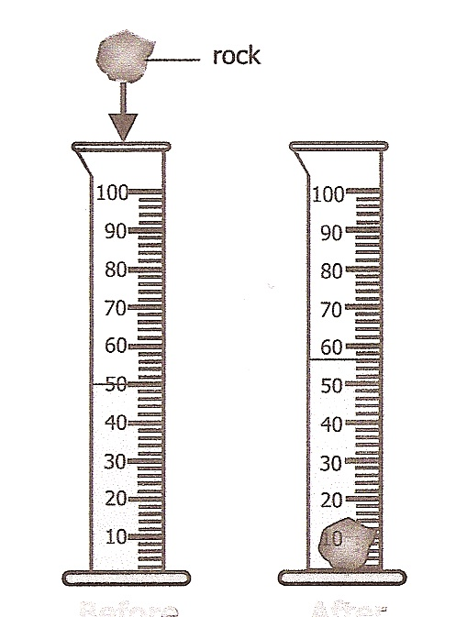
Look at the graduated cylinders below very closely. Answer the questions.
Before After B

1. What is the volume in
the Before graduated
cylinder? ____
2. What is the volume in
the After graduated
cylinder? ____
3. What made the volume in
the After graduated
cylinder increase? ____________
4. What is the difference
between the Before and
After graduated cylinders?
____________________
This is the volume of the rock!

Materials: water, plastic graduated cylinder, marble, rock, hex nut and medicine dropper

What To Do:
1. Place 30 mL of water in the graduated cylinder.
Don’t forget to use the dropper for accuracy.
2. Gently roll the marble down the side of the tilted
graduated cylinder so that you don’t splash water out of the cylinder.
3. Record the new volume.
4. Find the difference by subtracting the ending
volume from the beginning volume, as shown below.
5. Pour out the water and marble.
6. Refill the graduated cylinder to 30 mL.
7. Find the volume of the rock.
8. Repeat and find the volume of the hex nut.
Ending volume ______

Beginning volume - 30 mL

Volume of marble _______
Ending volume ______

Beginning volume - 30 mL

Volume of rock _______

Ending volume ______

Beginning volume - 30 mL

Volume of hex nut _______

You are given a graduated cylinder; water, a medicine dropper and a door key explain how you would find
the volume of the door key.

Work with a partner and write the steps below.

Directions:
1. Watch the video “ How Taking a Bath . .” from www.missdoctorbailer.com.
2. Answer the following questions.

Questions:
1. What did the king think happened?
______________________________________________
______________________________________________
______________________________________________

2. What was the irregular solid that Archimedes had to investigate?

______________________________________________

3. Explain what he did.
______________________________________________
______________________________________________
______________________________________________
4. What do you think happened to the guy who made the crown?
______________________________________________
______________________________________________

5. What is the technique for using water to find the volume of an irregular solid called? ________________

Name _______________ period ____

EXIT TICKET
Finding the Volume of an Irregular Solid
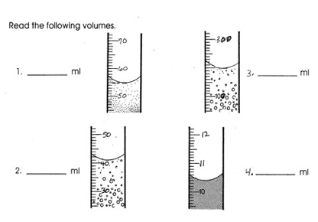

Conclusion: (mL, space, difference, displacement ending, bottom)
To find the volume of an irregular object you must find the _______ between the beginning and ________ volume. The technique of using water to find the volume is called ______________. The unit for volume is _______. Volume is defined as the amount of _______ an object takes up. When reading the amount of liquid in a glass graduated cylinder you must read at the ___________ of the meniscus.

Name _______________ period ____

EXIT TICKET
Finding the Volume of an Irregular Solid

Conclusion: (mL, space, difference, displacement ending, bottom)
To find the volume of an irregular object you must find the _______ between the beginning and ________ volume. The technique of using water to find the volume is called ______________. The unit for volume is _______. Volume is defined as the amount of _______ an object takes up. When reading the amount of liquid in a glass graduated cylinder you must read at the ___________ of the meniscus.

