Classifying Invertebrates
Scientists have identified at least 1.7 million kinds of organisms on Earth. It is important for biologists to have the living things organized into groups. Classification is the process of grouping things based on their shared traits. Biologists use classification to organize living things into groups so that the organisms are easier to study.
Animals are classified into two major groups. One group is made up of animals with backbones – called vertebrates. The other group is made up of animals without backbones. Animals without backbones are called invertebrates. Most animals are invertebrates. In fact, invertebrates make up 97% of the animal kingdom.

The table below identifies some characteristics of invertebrates and vertebrates.
1. Look at the pictures and determine which animals are vertebrates and which are invertebrates.

Invertebrates | - Has external skeleton  - Has no legs or more than four  - May have a shell  - Do not have hair or fur
Vertebrates | - Has internal skeleton  - Has 2-4 legs  - Mammals have fur
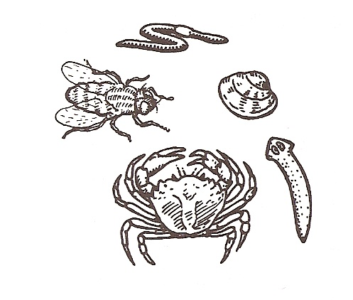
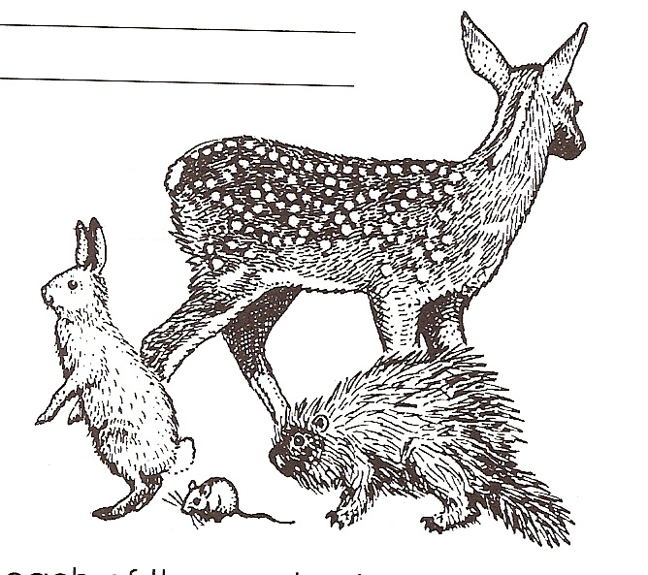
2. Color the
invertebrates
yellow.

3. Color the
vertebrates
blue.

Materials: Invertebrate cards and titles, Invertebrate Trait Sheet
What To Do:
1. Find the bag with the invertebrate cards and titles.
2. Place the titles in a row across your table.
3. Use the Animal Traits Sheet to determine into which group the animals belong.
4. Write your answers below.
5. There are a few pictures that are not listed on the traits paper. Predict in which group you would find them.

Phylum | Examples
Sponges
Cnidarians
Flatworms
Roundworms
Segmented Worms
Mollusks
Echinoderms
Arthropods
Questions:
1. Which phylum had the most members? __________
2. Which phylum had the least members? __________

Directions:
1. Watch the video Arthropods from www.missdoctorbailer.com.
2. Listen for the following answers then discuss them with your partners.

Questions:

1. How many different arthropods are there? ___________________________________________

2. What is an exoskeleton? _____________________

3. What is the most impressive adaptation of the arthropods?

_________________________________________________

4. Which of the following is not an arthropod?

insects centipedes bats scorpion

5. What does a praying mantis eat? ________________

6. How are arthropods beneficial to the environment?
______________________________________________
______________________________________________

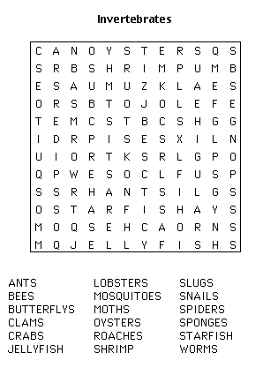

Name ____________________ period _____

EXIT TICKET
Classifying Invertebrates
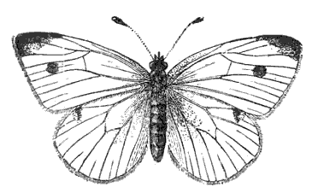
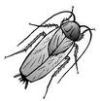
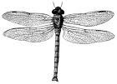
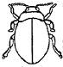
A
B
C
D
A
B
C
D

Order of Arthropod | Characteristics
Odonata | 2 pair of wings that can’t be folded
Dictyoptera | Flattened body and long antenna
Coleoptera | Four wings with top pair protecting second pair
Lepidoptera | Four large wings
Using the information in the chart answer the following questions.

1. Which insect is from the Order Dictyoptera?
A B C D

2. Which insect is from the Order Lepidoptera?

A B C D

Name ____________________ period _____

EXIT TICKET
Classifying Invertebrates

Order of Arthropod | Characteristics
Odonata | 2 pair of wings that can’t be folded
Dictyoptera | Flattened body and long antenna
Coleoptera | Four wings with top pair protecting second pair
Lepidoptera | Four large wings
Using the information in the chart answer the following questions.

1. Which insect is from the Order Dictyoptera?
A B C D

2. Which insect is from the Order Lepidoptera?

A B C D

