Name ___________________ period _____
DO NOW
WEEK 1
8.5A Describe the structure of atoms including the masses, electrical charges, and locations of protons and neutrons in the nucleus and electrons in the electron cloud.

Date _____________

The Bohr Model of an atom was developed by a Danish physicist name Neils Bohr. He thought that electrons moved around the nucleus in orbits called energy levels. In the Bohr Model below, name the subatomic particles and tell how many of each kind are found in this atom of Helium.
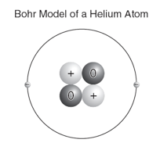
1. Underline the question.

2. Box the important vocabulary words.

3. Tell something else you know about this topic.

_________________________________________
_________________________________________

4. Answer the question in the space below.

Date ______________

The Periodic Table tells us the atom number and atomic mass of each element. It also tells us the symbol and name of the element. What is the total number of electrons in an atom with at atomic number of 13 and a mass number of 25?

1. Underline the question.

2. Box the important vocabulary words.

3. Tell something else you know about this topic.
_________________________________________
_________________________________________

4. Answer the question in the space below.

Date ________________

Atoms are the basic building block of most of the matter around you. An atom is made up of three different kinds of particles. What is the relationship between protons and electrons in a neutral atom?

1. Underline the question.

2. Box the important vocabulary words.

3. Tell something else you know about this topic.
_________________________________________
_________________________________________

4. Answer the question in the space below.

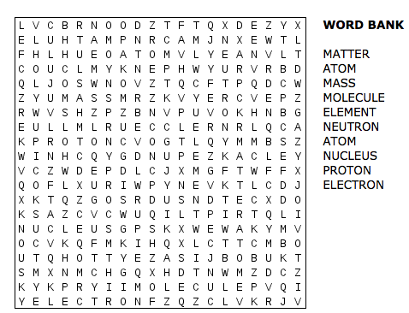
Date _______________

The modern model of the atom is the electron cloud model. There are two types of particles in the nucleus and one type of particle in the electron cloud. Fill in the table below to show the name, location and charge of each subatomic particle.

1. Underline the question.

2. Box the important vocabulary words.

3. Tell something else you know about this topic.
_________________________________________
_________________________________________

4. Answer the question in the space below.

Particle | Electrical Charge | Location



