Name ___________________ period _____
DO NOW
WEEK 2
8.5A Describe the structure of atoms including the masses, electrical charges, and locations of protons and neutrons in the nucleus and electrons in the electron cloud.
Date _____________

Atoms contain three different types of particles. Protons and neutrons are found in the nucleus while the electrons are found in the electron cloud. The mass of an atom depends on which of these particles?

1. Underline the question.

2. Box the important vocabulary words.

3. Tell something else you know about this topic.

_________________________________________
_________________________________________

4. Answer the question in the space below.

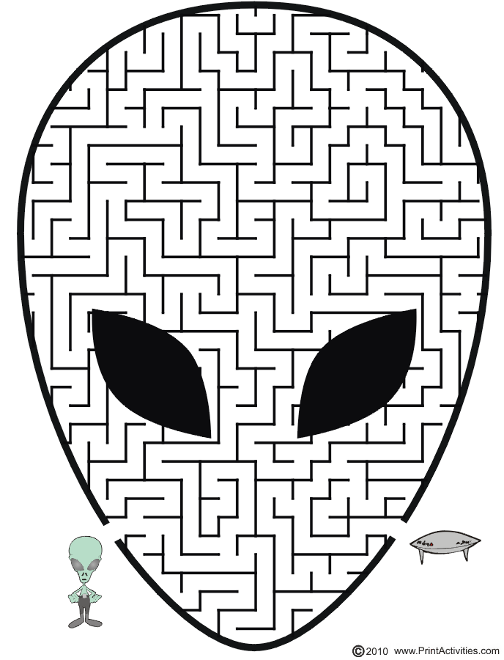

Date ______________

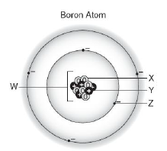
Every atom has at least 1 energy level in the electron cloud. The most energy levels an atom can have is 7. Name what each letter in the picture below represents.

1. Underline the question.

2. Box the important vocabulary words.

3. Tell something else you know about this topic.
_____________________________
_________________________________________

4. Answer the question in the space below.

Date ______________

When electrons have a great deal of energy they fly around near the outside edge of the electron cloud. When they lose their energy they drop back down toward the middle of the atom. What structure in the atom do the electrons with less energy get close to?

1. Underline the question.

2. Box the important vocabulary words.

3. Tell something else you know about this topic.
_________________________________________
4. Answer the question in the space below.

8.5B Identify that protons determine an element’s identify, and valence electrons determine its chemical properties including reactivity.

Date _______________
In an atom, the subatomic particles may have either a positive charge, a negative charge or be neutral. Name the subatomic particle that determines an atom’s identity.

1. Underline the question.

2. Box the important vocabulary words.

3. Tell something else you know about this topic.
_________________________________________
_________________________________________

4. Answer the question in the space below.

Date _____________
Elements are placed in groups on the Periodic Table according to their chemical properties. Which particle accounts for the similarities in the chemical properties of these elements?
1. Underline the question.

2. Box the important vocabulary words.

3. Tell something else you know about this topic.
_________________________________________
_________________________________________

4. Answer the question in the space below.

