Name ___________________ period _____
8th grade DO NOW
WEEK 3
8.5B Identify that protons determine an element’s identify, and valence electrons determine its chemical properties including reactivity.
Date _____________
The periodic table gives the element’s symbol and name. It also gives the atomic mass and atomic number. What should you do to find the number of protons in an element?
1. Underline the question.
2. Box the important vocabulary words.
3. Tell something else you know about this topic.

_________________________________________
_________________________________________

4. Answer the question in the space below.

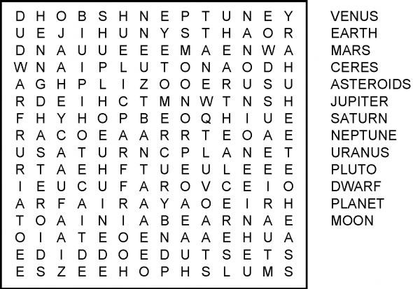

Date ______________

The group number is found at the top of each column on the periodic table. Each group has a different set of chemical properties such as being very reactive and others being non reactive. What structure accounts for the similarities in the chemical properties of elements?

1. Underline the question.

2. Box the important vocabulary words.

3. Tell something else you know about this topic.
_____________________________
_________________________________________

4. Answer the question in the space below.

Date ______________

Elements are placed in the same group because they have the same reactivity. What element has the same number of valance electrons as Neon?

1. Underline the question.

2. Box the important vocabulary words.

3. Tell something else you know about this topic.
_________________________________________
_________________________________________
4. Answer the question in the space below.

