Name ___________________ period _____
DO NOW
WEEK 4
8.5C Interpret the arrangement of the Periodic Table including groups and periods, to explain how properties are used to group elements.
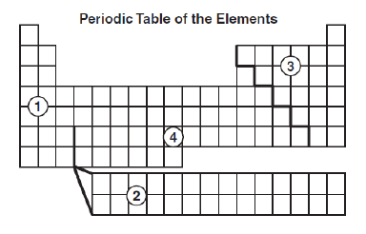
Use this Periodic Table for the next questions.

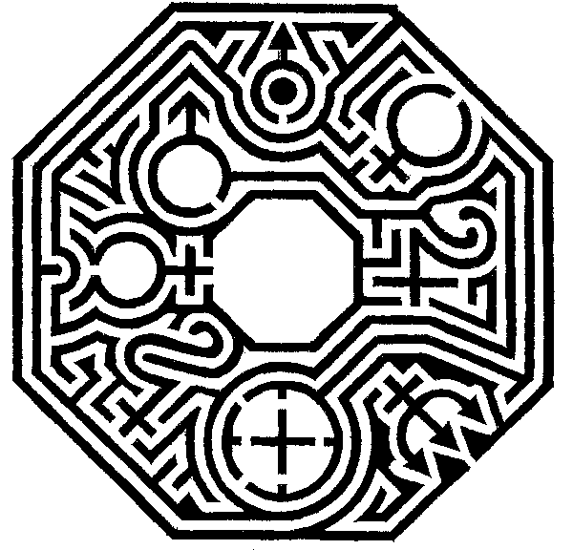

Date _______________

Elements on the Periodic Table are classified as metals, nonmetals and metalloids. An element has a yellow appearance and is dull, brittle and non-conductive. In which section would it be located and what type of element is it?
1. Underline the question.

2. Box the important vocabulary words.

3. Tell something else you know about this topic.
_________________________________________
_________________________________________
4. Answer the question in the space below.

Date ______________
When elements are placed on the periodic table they a placed in groups according to their physical properties. An element has a silver appearance, is shiny, malleable and conducts heat and electricity. In which section would it be located and what type of element is it?

1. Underline the question.

2. Box the important vocabulary words.

3. Tell something else you know about this topic.
_________________________________________
_________________________________________
4. Answer the question in the space below.

Date _______________
Some elements have physical properties of both metals and nonmetals. An element has a metallic-grey appearance but does not conduct electricity.
In which section would it be located and what type of element is it?

1. Underline the question.

2. Box the important vocabulary words.

3. Tell something else you know about this topic.
_________________________________________
_________________________________________

4. Answer the question in the space below.

Date _____________
Use your own Periodic Table for the next two questions.
The elements Ne, Ar, Kr and Xe are all in the same group. Why have they been placed in group 18?
1. Underline the question.

2. Box the important vocabulary words.

3. Tell something else you know about this topic.
_________________________________________
_________________________________________

4. Answer the question in the space below.

Date _______________
The number of protons tells the identity of an element and the number of electrons. Write a list of 4 elements that increase in the number of protons and write the number of protons beside the symbol.

1. Underline the question.

2. Box the important vocabulary words.

3. Tell something else you know about this topic.
_________________________________________
_________________________________________

4. Answer the question in the space below.

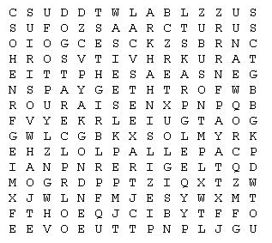

Achernar Arcturus Betelgeuse Canopus
Capella Dogstar Eagle Foot Goat
Kentaurus Procyon Rigel Sirius Vega

