Name ___________________ period _____
8th grade DO NOW
WEEK 7
8.6B Differentiate between speed, velocity and acceleration
Date ______________
Speed can be expressed in meters per second, miles per hour or kilometers per hour. Write three examples of speed with its appropriate units.

1. Underline the question.

2. Box the important vocabulary words.

3. Tell something else you know about this topic.
_________________________________________
_________________________________________
4. Answer the question in the space below.

Date ______________
Velocity is expressed as a speed with a direction. Write three examples of velocity with its appropriate units.

1. Underline the question.

2. Box the important vocabulary words.

3. Tell something else you know about this topic.
_________________________________________
_________________________________________
4. Answer the question in the space below.

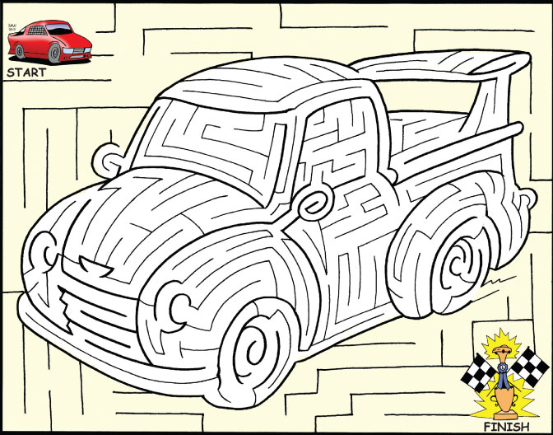

Date ______________
Acceleration is a change in speed or a change in direction. What are the units for acceleration?

1. Underline the question.

2. Box the important vocabulary words.

3. Tell something else you know about this topic.
_________________________________________
_________________________________________
4. Answer the question in the space below.

Date _______________
An object is moving 45 meters per second, southwest.
Name 3 ways you can change the velocity of this object.

1. Underline the question.

2. Box the important vocabulary words.

3. Tell something else you know about this topic.
_________________________________________
_________________________________________

4. Answer the question in the space below.

