Name ___________________ period _____
8th grade DO NOW
WEEK 8
8.6C Investigate and describe applications of Newton’s Laws
Date ______________
Newton’s 1st law, called the Law of Inertia, says that objects in motion will stay in motion unless acted upon by an unbalanced force. If a car and driver hit a wall going 60 km/h and the driver is not wearing a seatbelt, in which direction will the driver leave the car?

1. Underline the question.

2. Box the important vocabulary words.

3. Tell something else you know about this topic.
_________________________________________
_________________________________________
4. Answer the question in the space below.

Date ______________
According to the Law of Inertia, if a car and driver hit a wall going 60km/h and the driver is not wear a seatbelt, how fast will the driver be going when he leaves the car

1. Underline the question.

2. Box the important vocabulary words.

3. Tell something else you know about this topic.
_________________________________________
_________________________________________
4. Answer the question in the space below.

Date ______________
Newton’s 3rd law, called the Law of Action-reaction, states that when one object exerts a force on a second object, the second object ---

1. Underline the question.

2. Box the important vocabulary words.

3. Tell something else you know about this topic.
_________________________________________
_________________________________________
4. Answer the question in the space below.

Date ______________
Newton’s 2nd law, called the Law of Force and Acceleration tells us the relationship between force, mass and acceleration. Write the equation for that relationship in the space below.

1. Underline the question.

2. Box the important vocabulary words.

3. Tell something else you know about this topic.
_________________________________________
_________________________________________
4. Answer the question in the space below.

Date _______________
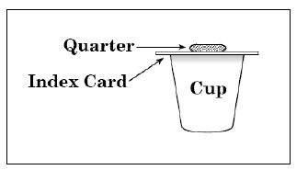
When the card is give a quick and hard horizontal push to the right, what will happen to the card and the quarter?

1. Underline the question.

2. Box the important vocabulary words.

3. Tell something else you know about this topic.
_________________________________________
_________________________________________

4. Answer the question in the space below.

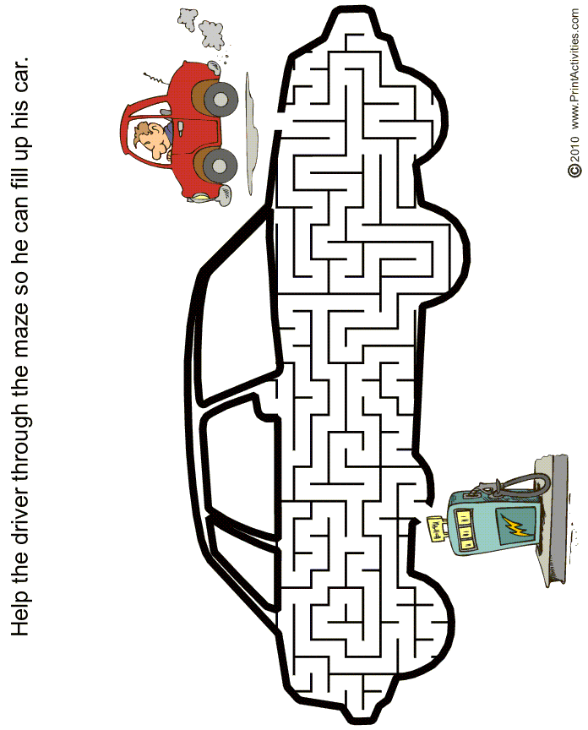

The kids tried all kinds of rides. Help them get from one to the other! Start at the bold letter B at the bottom of the Ferris wheel. Look for the name of the first ride on the list. Then follow the name chain--the last letter of the first ride will be the first letter of the next ride on the list. HINT: Words might not be in a straight line; they can turn diagonally in the middle or up or down!

BUMPER CARS SWINGS SCRAMBLER ROLLERCOASTER ROUNDUP PARATROOPER
