Name ___________________ period _____
8th Grade DO NOW
WEEK 9

Date _____________
Match the structures found in the atom with its definition

_____1. Proton A. Center of the atom, made
up of protons and neutrons

_____2. Neutron B. Smallest particle in the
atom, has a negative charge

_____3. Electron C. region in an atom where
electrons are found

_____4. Nucleus D. Particle in the nucleus
with a positive charge

_____5. Electron Cloud E. Particle in the nucleus
with no charge

Date ___________
Draw the structure of an atom and label each of the structures listed above.

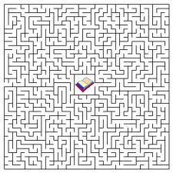

Date ________________
Match the information
_____1. Atomic Number A. Electrons with the most
energy are found here

_____2. Atomic Mass B. Number of electrons in
the last level of the
electron cloud of an atom

_____3. Valence Electrons C. found by looking at the
number of protons

_____4. Neutrons D. The average number of
protons and neutrons in
an atom

_____5. Far from nucleus E. number found by
subtracting the number
of protons from the
atomic mass

Date _______________
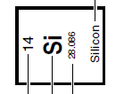
Match the name with the picture.
A

B

C
D

1._____ Atomic Number

2. _____Atomic Mass

3. ______Symbol

4. _____ Name of element

5. _____ Number of protons

6. _____ Number of electrons

Date _______________
Pick one of the first 20 elements from your periodic table and draw the structure with the nucleus, proton number, neutron number, electron cloud and energy levels with electrons.

