Name ___________________ period _____
8th Grade DO NOW
WEEK 10
8.11A Describe producer/consumer, predator/prey, and parasite/host relationships as they occur in food webs in marine, freshwater and terrestrial ecosystems.
Date _____________
Match the vocabulary word with its meaning.

_____ 1. Predator A. All living and nonliving
things in an area

_____2. Prey B. Animal that kills other
animals

_____3. Producer C. an organism that feeds on
other organisms

_____4. Consumer D. Organism that is killed and
eaten by another organism

_____5. Ecosystem E. Organism that makes its
own food
Date ___________

Word | Example
Predator
Prey
Producer
Consumer
Ecosystem

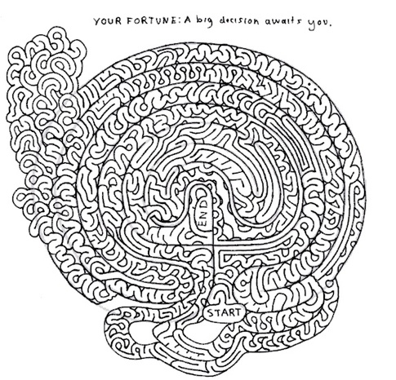

Date ________________

Word | NON-Example
Predator
Prey
Producer
Consumer
Ecosystem

Date _______________
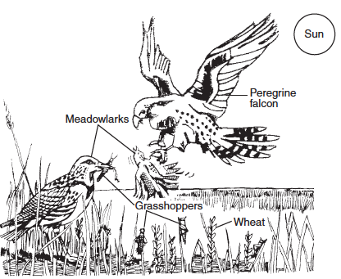
Use the picture to answer the following questions.
1. Give an example of a predator. _________________
2. Give an example of a prey. ____________________
3. Give an example of a producer. ________________
4. Give an example of a consumer? _______________
5. From where does the energy for the ecosystem come? ___

Date _______________

1. Can the meadowlarks be considered predators? ______
2. Explain your thinking. ___________________________
________________________________________________
3. Can the grasshoppers be considered predators? _______
4. Explain your thinking. ___________________________
________________________________________________

