Name ___________________ period _____
8th Grade DO NOW
WEEK 11
8.11A Describe producer/consumer, predator/prey, and parasite/host relationships as they occur in food webs in marine, freshwater and terrestrial ecosystems.
Date _____________
Match the vocabulary word with its meaning.

_____ 1. Decomposer A. Arrangement of several
overlapping food chains
in an ecosystem.

_____2. Parasite B. An organism that breaks
down dead organisms
and wastes

_____3. Host C. an organism that feeds
on other organisms causing
harm to that organism

_____4. Competition D. Organism that supports a
parasite

_____5. Food Web E. Occurs when more than one
individual tries to make use
of the same limited resource
Date ___________

Word | Example
Decomposer
Parasite
Host
Competition
Food Web

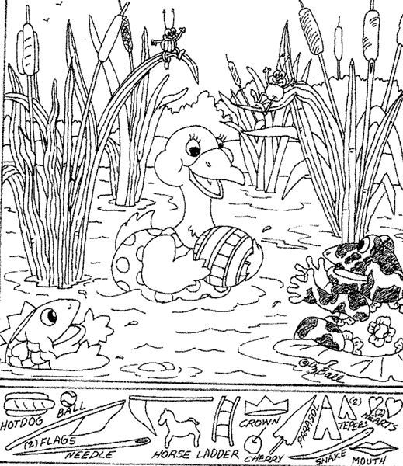

Date ________________

Word | NON-Example
Decomposer
Parasite
Host
Competition
Food Web

Date _______________
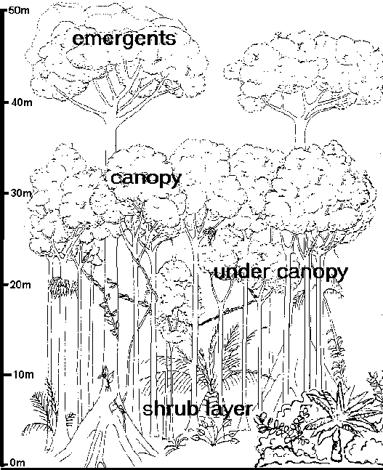

1. Which resource does the shrub layer in the rainforest have to compete for? ___________________________________
2. Which resource do none of the plants of the rainforest have to compete for? ____________________________
