Name ___________________ period _____
8th Grade DO NOW
WEEK 12

Date _____________
Match the body system with its function

_____1. Digestive A. Secretes hormones which
regulate body functions

_____2. Nervous B. Provides a barrier for
protection between the
body and the environment

_____3. Endocrine C. Breaks down food into
nutrients the body can use

_____4. Circulatory D. detects and responds to
changes in the
environment

_____5. Integumentary E. Transports materials to
the cells and wastes away
from the cells

Date ___________

System | Major Organ
Digestive
Nervous
Endocrine
Circulatory
Integumentary

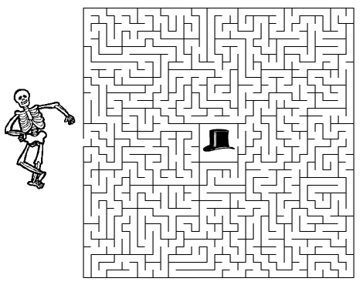

Date ________________
Match the body system with its function

_____1. Respiratory A. supports and protects the
body

_____2. Reproductive B. moves the body

_____3. Muscular C. removes wastes produced
by the body

_____4. Skeletal D. Produces offspring

_____5. Excretory E. Exchanges oxygen and
carbon dioxide

Date _______________

System | Major Organ
Respiratory
Reproductive
Muscular
Skeletal
Excretory

Date _______________

Systems | How they work together
Respiratory and Circulatory

Digestive and Excretory

Digestive and Circulatory

Skeletal and Muscular

