Seeds and Forces
We have learned that work requires force over a distance. But what exactly is a force? The science definition of force is a push or a pull. There are many forces acting on us right now. The force of gravity pulls us toward the center of the earth. The force of the floor is pushing us upwards. When we walk the force of friction keeps us from sliding around. Inside our bodies our heart pumps the blood using a force – a push!
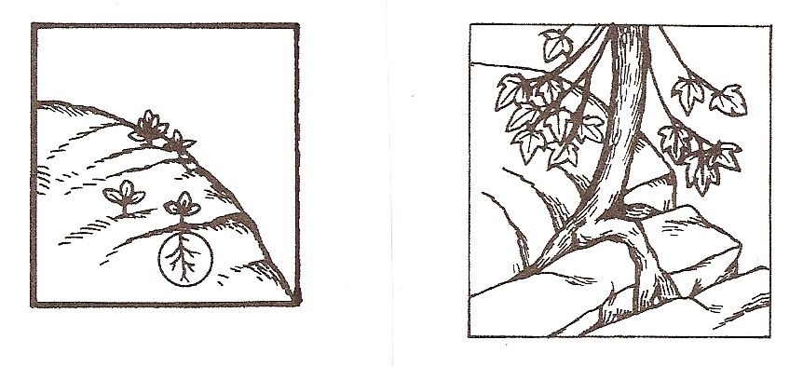
Forces work on plants, too and many of there are very strong! Have you ever seen a sidewalk that has been pushed up by the roots of a tree? What about a tree growing out of a rock?
When seedlings emerge from the seed,
the roots grow down into the soil and it must push the soil and tiny rocks away. If a seed lands on a rock it will force a rock to break apart so the roots can continue to grow. As the stem grows up toward the surface it must push its way through the soil. As we know a force is a push or a pull. So plants have forces pushing down and forces pushing up at the same time.

Materials: clear plastic cup, 5 spoonfuls plaster of Paris, 4 dry kidney bean seeds, 5 spoonfuls of water

What To Do:
1. Mix the Plaster of Paris with the 5 spoonfuls of water.
It should be thick.

2. Place the kidney bean seeds on the surface and push down with the end of the spoon very gently so most of the beans are covered with the Plaster of Paris. Leave the tip of the bean showing.
3. Observe while the Plaster of Paris dries.
4. During the next class add 2 tablespoons of water to the top of the Plaster of Paris.
5. Look for any evidence of your seeds growing.
6. Draw what you observe after day 3.

Day 3 Day 4 Day 5
With your knowledge of germination and seed growth write 3 sentences in the space below predicting what you will observe as the seed begin to grow. Use the following words:
Seedling force emerge root stem

Another force works inside the plant cells. This force is called turgor pressure. This force pushes against the cell wall of a plant cell and allows the plant to stand up right. This pressure comes from the water inside the large vacuole in each plant cell.

Osmosis is the process that enables water to cross the cell membrane and move into the vacuole. If plants do not have enough water and lose turgor pressure then they wilt and are not able to stand up.

Watch the two videos from www.missdoctorbailer.com and describe what you observe in the space below.

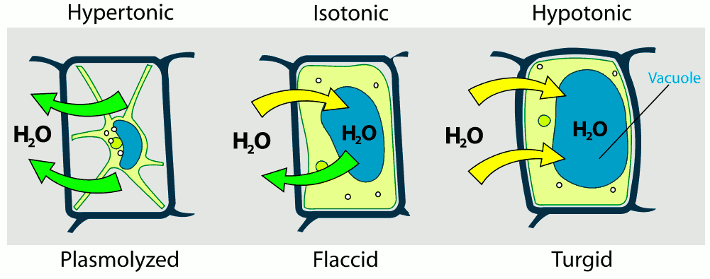
A B C
1. Which of the cells have the highest turgor pressure?_____
2. Which of the cells have the lowest turgor pressure?_____
3. If the turgor pressure is high, the plant can stand up. In which of the cells above is the plant standing up? _______
4. If the turgor pressure is very low the plant is dying. In which of the cells above is the plant dying? _________
5. If the turgor pressure is low the plant is wilting. In which of the cells above is the plant wilting? _______

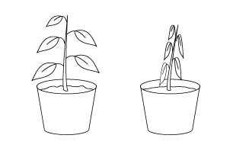

The pictures above show the same plant. The first picture shows the plant in normal circumstances. The second picture shows the plant after the family returned from a two week vacation. Describe what happened to the plant. Be sure to use the following words:
Turgor pressure wilt or wilted water

Watch the BrainPop on Carnivorous Plants. Match the plants below with the type of trap they use.
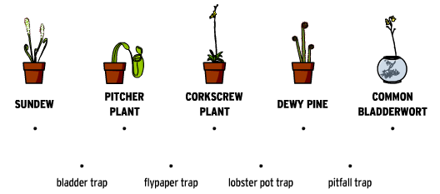

How do Venus Flytraps use turgor pressure to capture insects? ________________________________________

Name _________________ period _____

EXIT TICKET
Forces and Plants
1. What is the science definition for force?
A. a push
B. a pull
C. a push or a pull

2. What is turgor pressure?

A. The pressure that keeps the chloroplasts inside
The plant cell
B. The pressure that keeps all living things on the
ground
C. The pressure that keeps a plant standing up

3. What is wilting?

A. When a plant doesn’t have enough water and
can’t stand up
B. When a plant can’t use the Sun for photosynthesis
C. When a plant has too much water

4. How do plants break up rocks?

A. They pull the soft soil away
B. Their roots push into the rocks
C. Their leaves cause the roots to rot

5. Which of the following is NOT a carnivorous plant?

A. Venus Fly Trap
B. Daisy
C. Pitcher Plant

Name _________________ period _____

EXIT TICKET
Forces and Plants
1. How do plants break up rocks?

A. They pull the soft soil away
B. Their roots push into the rocks
C. Their leaves cause the roots to rot

2. Which of the following is NOT a carnivorous plant?

A. Venus Fly Trap
B. Daisy
C. Pitcher Plant

3. What is the science definition for force?
A. a push
B. a pull
C. a push or a pull

4. What is turgor pressure?

A. The pressure that keeps the chloroplasts inside the
plant cell
B. The pressure that keeps all living things on the
ground
C. The pressure that keeps a plant standing up

5. What is wilting?

A. When a plant doesn’t have enough water and can’t
stand up
B. When a plant can’t use the Sun for photosynthesis
C. When a plant has too much water

