Plants and Tropisms
Plants can’t move like animals can but they will still respond to a stimulus, or change in the environment. A plant growth in response to a stimulus is called a tropism. Plants respond to stimuli such as gravity, light and touch.
The force of gravity can affect an object even if it is not falling toward the Earth. For example, have you ever noticed that most plants grow vertically – not sideways or downward? The reason is that plants respond to the force of gravity. This response to gravity is known as geotropism. Geo means the earth. No matter how a seed is positioned in the soil, its stem grows upwards and its roots grow downward. Roots grow in the direction of the gravitational force (positive geotropism), whereas stems grow in the opposite direction (negative geotropism).

Materials: paper towel, plastic bag, 4 kidney bean seeds
water, pencil, stapler, masking tape
What To Do:
1. Label your bag with the period and table number.
2. Fold the paper towel so that it will fit in the plastic bag and makes a pocket.
3. Poke 4 small holes with a sharp pencil in the bottom of the paper towel.
4. Place your paper towel inside the bag about 3 inches from the bottom.
5. Have your teacher staple the backside of the paper towel to the bag so that it doesn’t fall to the bottom.
6. Place 1 of the kidney bean seed on top of each hole. Put 2 facing up and 2 facing down.
7. Gently pour water into the bag so that it gets the paper towel damp but not soaking wet.

8. Hang your bag on a wall with tape.
9. Observe you seeds each day for week.
Observations:
1. Draw how your seeds were placed in the paper towel. Be sure to indicate the placement of the dot.
2. Each day add to your drawing.

Paper Towel

Answer these questions after the last day of observing.
Questions:
1. Which direction did all the roots grow? ___________
2. Why? _______________________________________
3. Which direction did all the stems and leaves grow? _______________________________________________
4. Why? _______________________________________
5. What force influences the seed the most? __________

If you place a plant near a window, you will notice that eventually, most of the leaves will be facing the sun. The leaves turn when cells on one side of the stem grow longer than cells on the other side. This change in the growth of a plant in response to light is called phototropism. Phototropism is important because plants need light to carry out photosynthesis.

Watch the video on phototropism on www.missdoctorbailer.com. Write down one observation in the space below.

______________________________________________
______________________________________________

Some plants respond to touch. For example, vines of beans, peas and other plants will grab onto and grow upward along a vertical support to maximize the amount of sun they receive. The leaves of the sensitive mimosa plant will close when touched. The response of a plant to touch is called thigmotropism.

Watch the videos on thigmotropism on www.missdoctorbailer.com. Write down one observation for each video in the space below.
_____________________________________________
_____________________________________________
_____________________________________________

Do not glue the next page until you have cut out the foldable. Glue only on the BACK on the TROPISM rectangle on page 59. Match the picture with the word and glue the picture to the lined paper. Write the definition of each word on the back of the word.

 | GEOTROPISM
TROPISMS | PHOTOTROPISM
 | THIGMOTROPISM

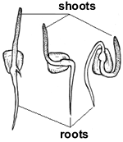
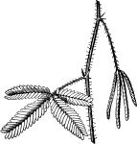
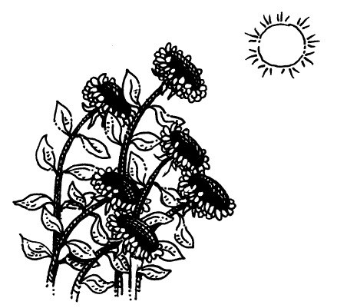

Name _______________ period _______
EXIT TICKET
Plants and Tropisms

1. What is the force that causes plant roots to grow
downward called?

A. friction
B. gravity
C. atomic

2. The response of plant to light is called –

A. geotropism
B. phototropism
C. thigmotropism

3. The response of plants to gravity is called –

A. geotropism
B. phototropism
C. thigmotropism

4. The response of plants to touch is called –

A. geotropism
B. phototropism
C. thigmotropism

5. What is the science definition of a force?

A. only a push
B. only a pull
C. a push or a pull

Name _______________ period _______
EXIT TICKET
Plants and Tropisms

1. The response of plants to gravity is called –

A. geotropism
B. phototropism
C. thigmotropism

2. The response of plants to touch is called –

A. geotropism
B. phototropism
C. thigmotropism

3. What is the science definition of a force?

A. only a push
B. only a pull
C. a push or a pull

4. What is the force that causes plant roots to grow
downward called?

A. friction
B. gravity
C. atomic

5. The response of plant to light is called –

A. geotropism
B. phototropism
C. thigmotropism

