Forest Habitat

These are the animals that were found in a survey of
a 1-meter x 1-meter microhabitat in a forest.

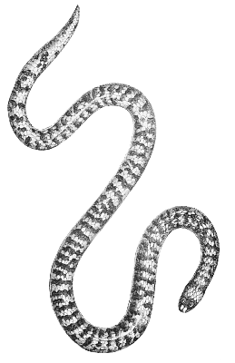  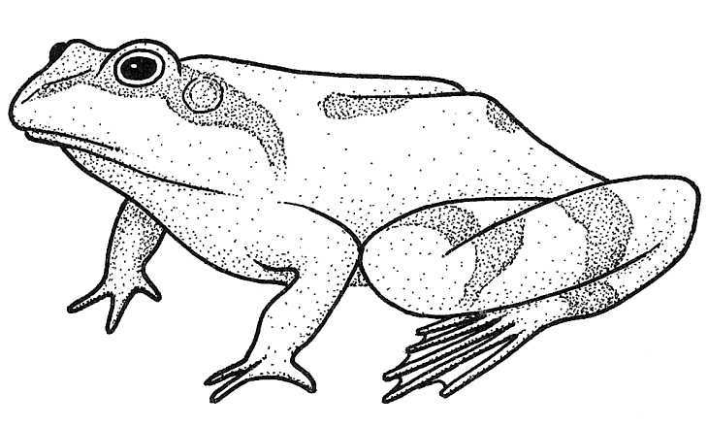Frog | 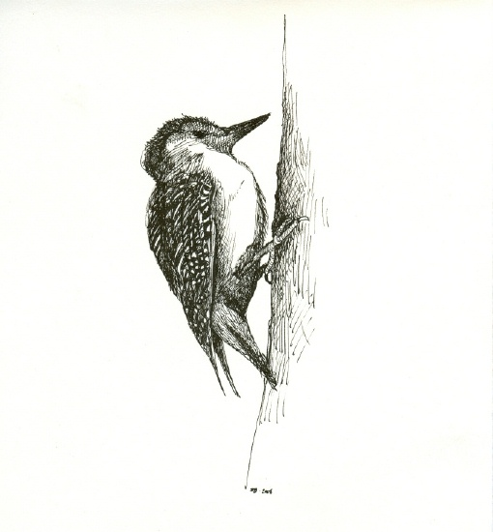  Woodpecker
Snake | 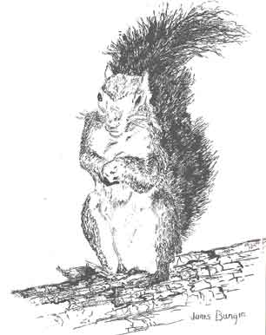Squirrel
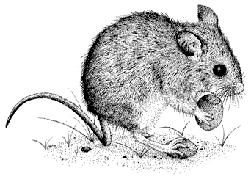Mouse | Squirrel
Squirrel | Frog
Woodpecker | Frog

Desert Habitat

These are the animals that were found in a survey of
a 1-meter x 1-meter microhabitat in a desert.

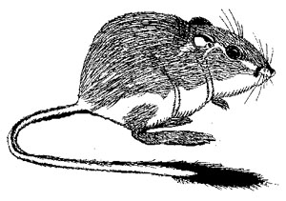  Kangaroo Rat |   Mojave Rattlesnake
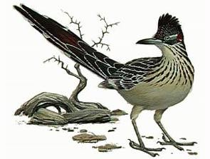  Roadrunner | Kangaroo Rat
Roadrunner | Roadrunner
Kangaroo Rat | Roadrunner
Mojave Rattlesnake | Kangaroo Rat

Tropical Rain Forest Habitat
These are the animals that were found in a survey of a
1-meter x 1-meter microhabitat in a tropical rain forest.

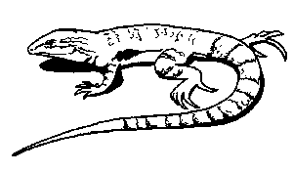  Lizard | 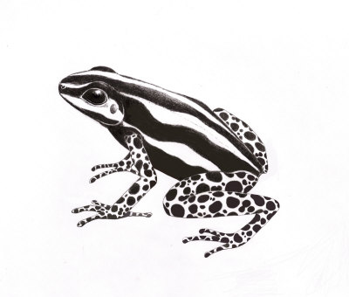  Poison dart frog
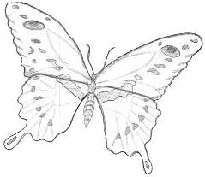  Butterfly | 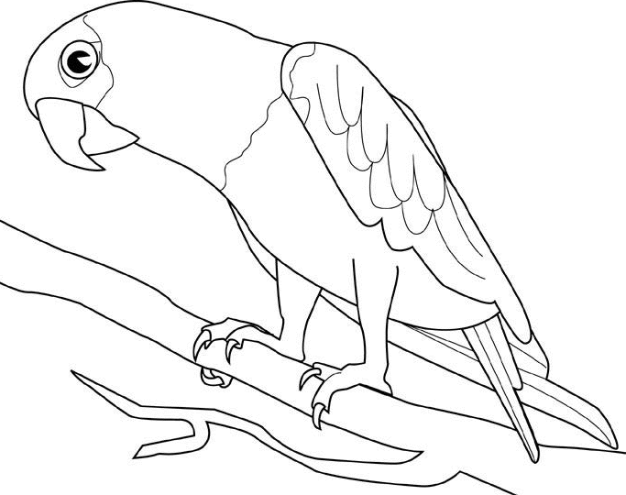  Parrot
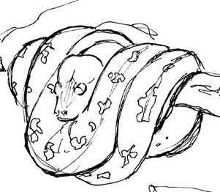  Green Tree Python |   Spider monkey
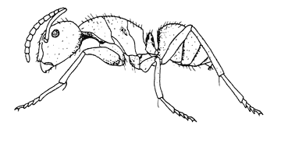Ant | Parrot
Ant | 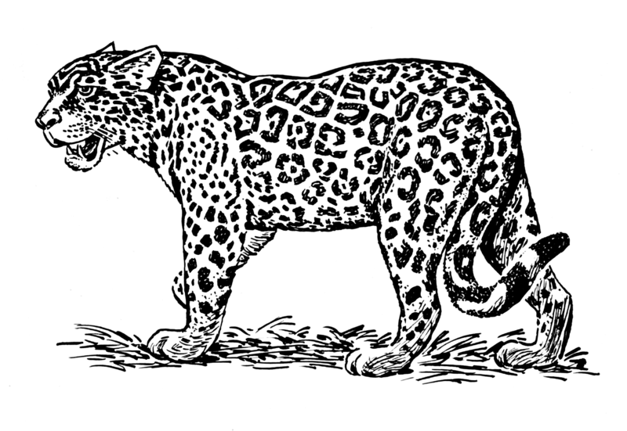  Jaguar

Tundra Habitat
These are the animals that were found in a survey of a 1-meter x 1-meter microhabitat in a tundra habitat.

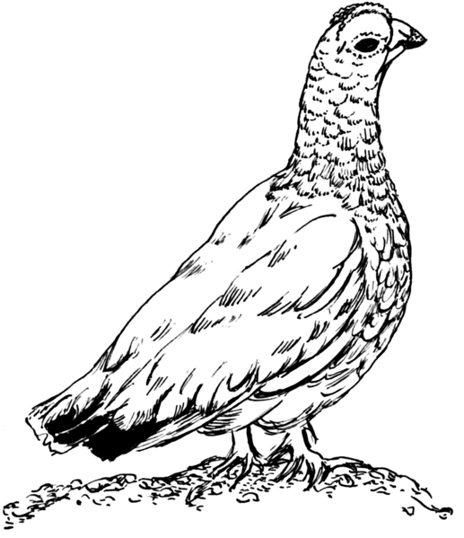  Ptarmigan |   Arctic tern
Arctic tern |   Arctic hare
  Arctic fox | Arctic tern
Arctic hare | Arctic fox
Arctic tern | Ptarmigan

