Name __________________ period _____
6th Grade Do Now
SCI.6.5A Know that an element is a pure substance represented by chemical symbols
SCI.6.6A Compare metals, nonmetals and metalloids using physical properties such as luster, conductivity or malleability

Monday Date _______________

Name three different metals that are used in your life.

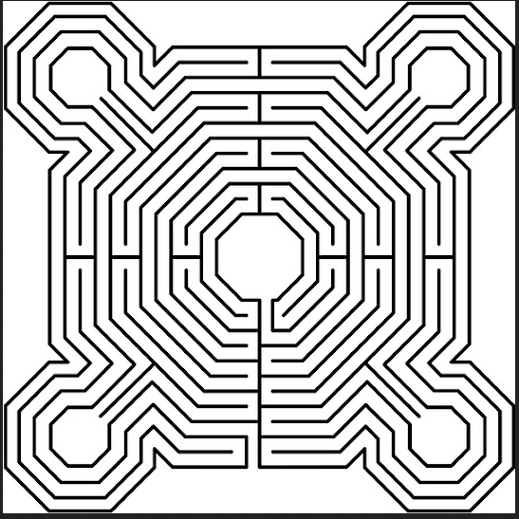

Tuesday Date _________________

Write the symbols of three nonmetals and three metalloids.

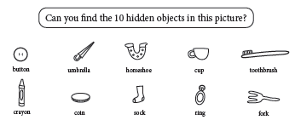

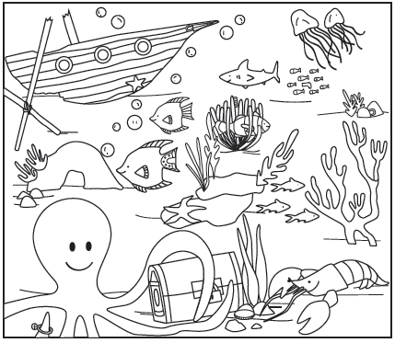

Wednesday Date ______________

Where do you find the metalloids on the Periodic Table?

A. On the right side
B. On the left side
C. In the last column
D. On the zigzag line that starts in group 13

Thursday Date ______________

Aluminum, sulfur and chlorine are elements found on the periodic table. Tests involving these three elements would show that at normal room temperature -

A. sulfur is malleable and aluminum conducts electricity
B. chlorine is malleable and conducts electricity
C. aluminum is malleable and conducts electricity
D. all three elements are malleable and conduct electricity

Friday Date ___________

Some students conducted a laboratory investigation to learn more about the physical properties of different elements. They observed four samples and recorded their observations in the table below.

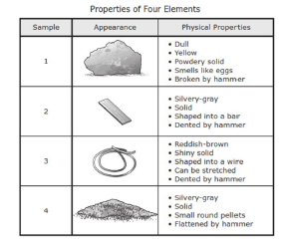
Based on these observations, which sample is most likely a nonmetal?

A. Sample 1
B. Sample 2
C. Sample 3
D. Sample 4

