Name __________________ period _____
6th Grade Do Now
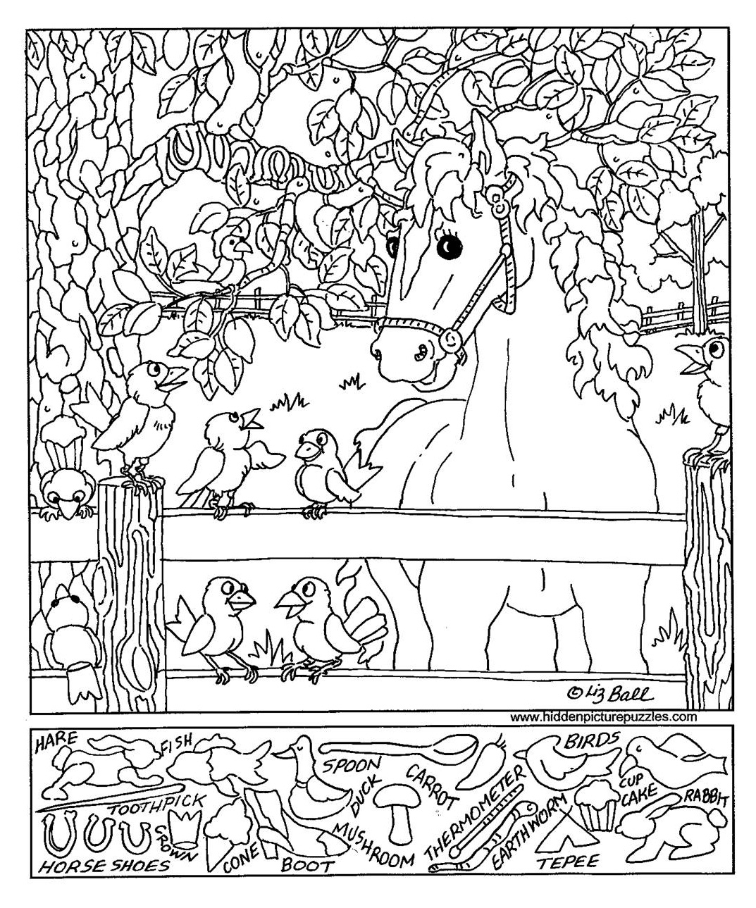
SCI.6.5DC Identify the formation of a new substance by using the evidence of a possible chemical change such as production of a gas, change in temperature, production of a precipitate, or color change.
ⓈSCI.6.6B Calculate density to identify an unknown substance.

Monday Date _______________

In elementary school you learned about the planets. You probably learned a sentence that helps you remember the order of the planets. Write that sentence below.

Tuesday Date _________________

Which of the following is NOT a clue that a chemical change has occurred?

A. A color change
B. A gas was produced
C. A powder dissolved in water
D. A change in temperature

Seek and Find

Wednesday Date __________

What is the special relationship between mass and volume called?

A. Density
B. Physics
C. Chemical change
D. Predictions

Thursday Date ___________

A manufacturer selected a metal to use in producing a lightweight button for clothing. A metal that has a density of 2.71 g/cm³ was selected.
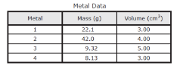
Which of the metals was selected?

A. Metal 1
B. Metal 2
C. Metal 3
D. Metal 4

Friday Date ______________

A balance and a graduated cylinder are used to determine the density of a rock. The sample has a mass of 15 g and a volume of 5cm³. What is the density of the rock?

A. 3 g/cm³
B. 0.33 g/cm³
C. 75 g/cm³
D. 5 g/cm³

