Name __________________ period _____
6th Grade Do Now
SCI.6.8A Compare and contrast potential and kinetic energy.

Monday Date _______________
Name two objects that have kinetic energy.

Tuesday Date _________________
A bicycle rider is traveling up a hill. When the rider reaches the top of the hill, she stops to rest. The diagram shows the rider in the three different positions.
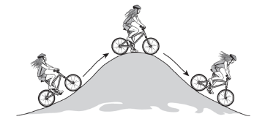

Which of these correctly describes the potential energy of the bicycle rider?

A. When the rider is at the top of the hill, her potential energy is the greatest, and her kinetic energy is the least.

B. As the rider moves up the hill, her kinetic energy increases, and her potential energy decreases.

C. When the rider goes down the hill, her potential energy increases, and her kinetic energy decreases.

D. As the rider reaches the bottom of the hill, her kinetic energy and her potential energy decrease.

Wednesday Date _______________
The drawing shows two identical airplanes at an air show. The airplanes are flying at the same speed. Airplane W is flying 50 m higher than Airplane X.

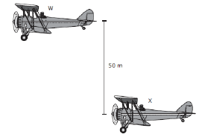

Which state best describes the energy of the two airplanes?

A. Airplane W has a greater kinetic energy than Airplane X.

B. The two airplanes have the same gravitational potential energy but different kinetic energies.

C. airplane X has more gravitational potential energy than Airplane W.

D. The two airplanes have the same kinetic energy but different gravitational potential energies.

Thursday Date __________
A student drew the diagram below to show the movement of water through a hydroelectric dam.

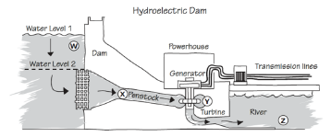
The student used the diagram to describe changes in the potential and kinetic energy of the water. At which location is the gravitational potential energy of the water the greatest?

A. Location W
B. Location X
C. Location Y
D. Location Z

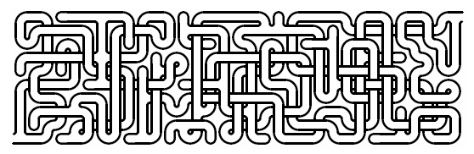

Are these lines parallel?

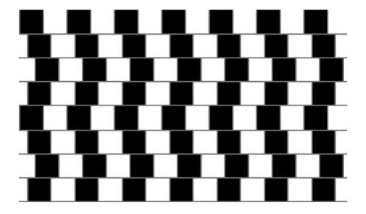
Friday Date ______________
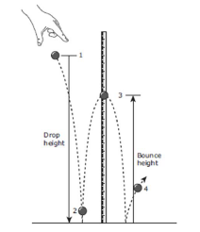
In the classroom demonstration below, a rubber ball is dropped from Position 1. The ball bounces as show.

At which of these positions does the ball have both the greatest kinetic energy and the least potential energy?

A. Position 1
B. Position 2
C. Position 3
D. Position 4

