Name __________________ period _____
6th Grade Do Now
6.9(C) demonstrate energy transformations such as energy in a flashlight battery changes from chemical energy to electrical energy to light energy

Monday Date _______________

Which of the following is NOT considered a form of energy?

A. Electrical
B. Light
C. Chemical
D. Vaporization

Tuesday Date _________________

A cook heats a meal in a microwave oven. What energy transformations occur between the microwave oven and the meal?
A. | Electrical energy |  | light energy |  | chemical energy
B. | Chemical energy |  | thermal energy |  | light energy
C. | Electrical energy |  | electromagnetic energy |  | thermal energy
D. | Chemical energy |  | electromagnetic energy |  | chemical energy

Wednesday Date ____________

The main parts of a working clothes dryer are shown in the diagram.
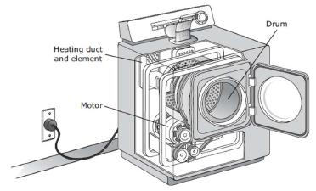
This appliance dries clothes primarily by
converting -

A. Electrical energy to heat and mechanical energy
B. Mechanical energy to heat and electrical energy
C. Electrical energy to heat and light
D. Mechanical energy to heat and vaporization

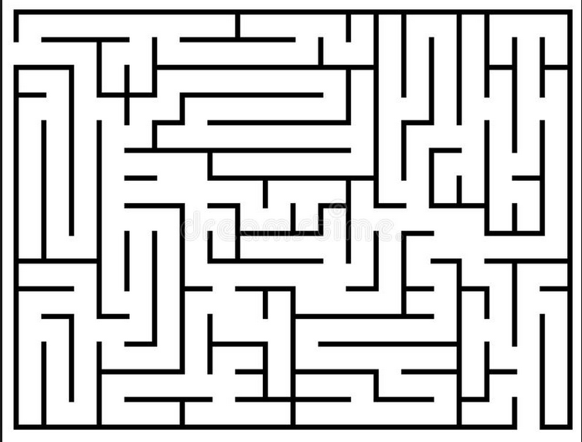
Thursday Date ___________

When a lion eats a zebra and then uses the energy to run, the lion’s body converts -

A. Chemical energy to mechanical energy
B. Electrical energy to chemical energy
C. Chemical energy to light energy
D. Mechanical energy to chemical energy

Friday Date _____________

The diagram below shows a hot air balloon rising. Propane gas tanks are seen at the bottom of the balloon.
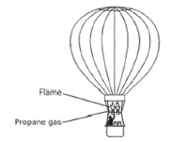
What energy transformations occur when propane gas is used to lift the balloon?

A. | Mechanical |  | light |  | chemical
B. | Chemical |  | mechanical |  | thermal
C. | Thermal |  | chemical |  | light
D. | Chemical |  | thermal |  | mechanical

