Name __________________ period _____
6th Grade Do Now
SCI.6.7A Research and discuss the advantages and disadvantages of using coal, oil, natural gas, nuclear power, biomass, wind, hydropower, geothermal, and solar resources.

Monday Date _______________

Name two renewable resources. Tell what makes them renewable.

Tuesday Date _________________

Name two nonrenewable resources. Tell what makes them nonrenewable.

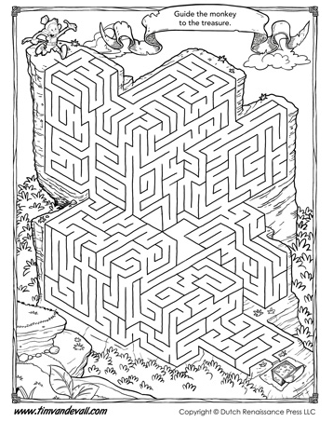

Wednesday Date _____________

Name two advantages of using coal.

Thursday Date ____________

Name two disadvantages of using coal.

Friday Date ___________

If given a choice of which type of resource you would use to generate your electricity which one would you choose? Give one reason why.


