Name __________________ period _____
6th Grade Do Now
SCI.6.9A Investigate methods of thermal energy transfer including conduction, convection, and radiation.
SCI.6.9B Verify through investigations that thermal energy moves in a predictable pattern from warmer to cooler until all the substances attain the same temperature such as an ice cube melting.

Monday Date _______________

What are the three states of matter?

Tuesday Date _________________

How is a substance’s thermal energy measured?

A. By counting the number of particles in the substance
B. By measuring how fast the particles are moving
C. By measuring its temperature
D. By touching it

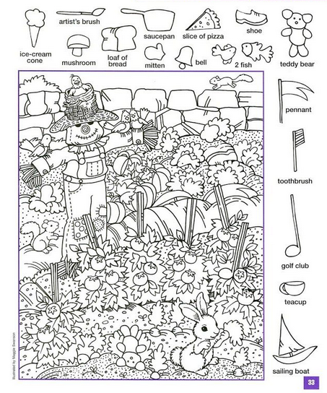

Wednesday Date ____________

Finish the following sentence:

Heat energy always transfers from ____________

________________________________________.

Thursday Date ___________

Conduction is -

A. The transfer of heat through direct contact
B. The transfer of heat by the movement of warmed matter.
C. The transfer of heat by electromagnetic waves.
D. The transfer of chemical energy to light energy

Friday ___________

Convection is -

A. The transfer of heat through direct contact
B. The transfer of heat by the movement of warmed matter.
C. The transfer of heat by electromagnetic waves.
D. The transfer of chemical energy to light energy

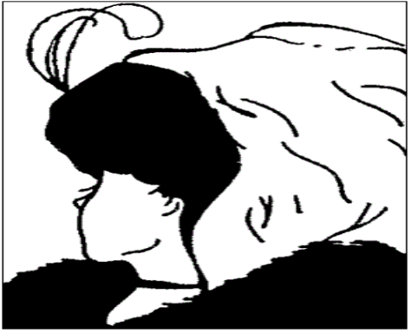
Can you see a young lady or an old lady? Or both?
