Name __________________ period _____
6th Grade Do Now
SCI.6.8C Calculate average speed using distance and time
measurements.

Monday Date _______________

What unit is used to measure distance?

A. Seconds
B. Meters
C. Newtons
D. Liters

Tuesday Date _________________

A bus travels 20 km in 30 minutes. What is the average speed of the bus?

A. 20 km/h
B. 30 km/h
C. 40 km/h
D. 50 km/h

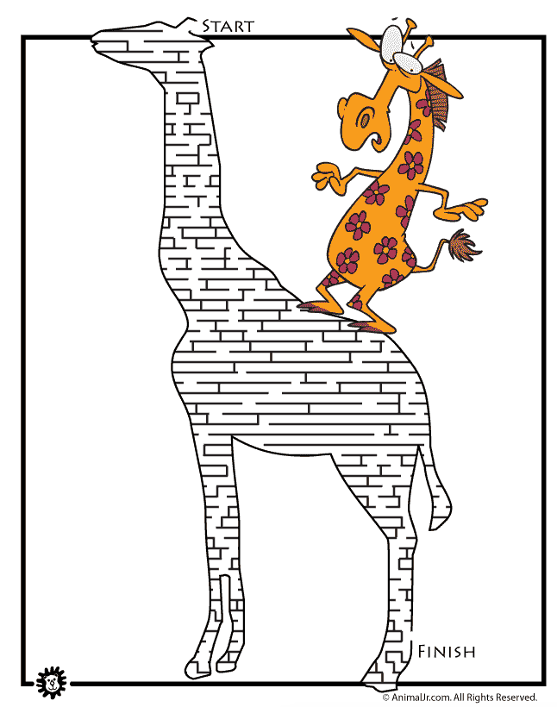

Wednesday Date ___________

The graph below shows the motion of a ball rolling on a straight track.
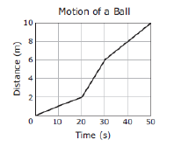
What was the ball’s average speed during the time represented in the graph?

A. 0.2 m/s
B. 0.5 m/s
C. 5.0 m/s
10.0 m/s

Thursday Date _____________

A student walks 2 km in 30 minutes. What is the student’s average speed in km/h?
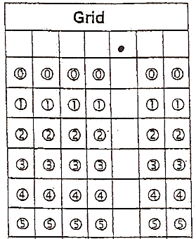

Friday Date _____________
Some students were investigating the speed of a toy car they build. They performed two trials and recorded the data in the table below.
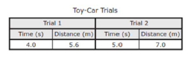
What was the average speed of the toy car during the two trials to the nearest tenth of m/s?

