Name __________________ period _____
6th Grade Do Now
SCI.6.8B Identify and describe the changes in position, direction, and speed of an object when acted upon by unbalanced forces.

Monday Date _______________

Describe what is happening in the picture below.

Tuesday Date _________________

What unit is used to measure force?

A. Meters
B. Liters
C. Grams
D. Newtons

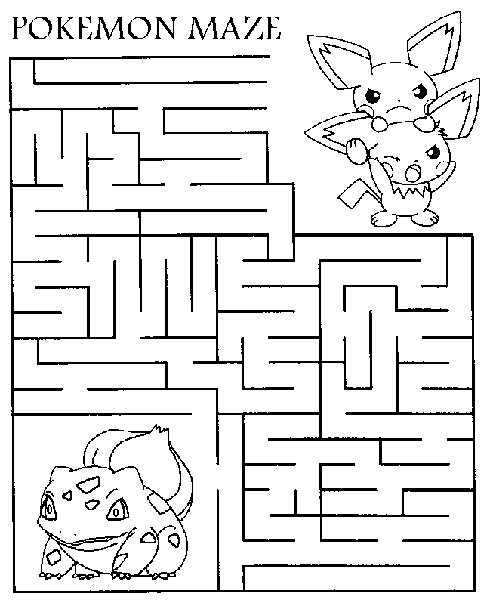

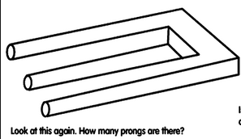

Wednesday Date _____________
In what direction and with what force will the box below move?

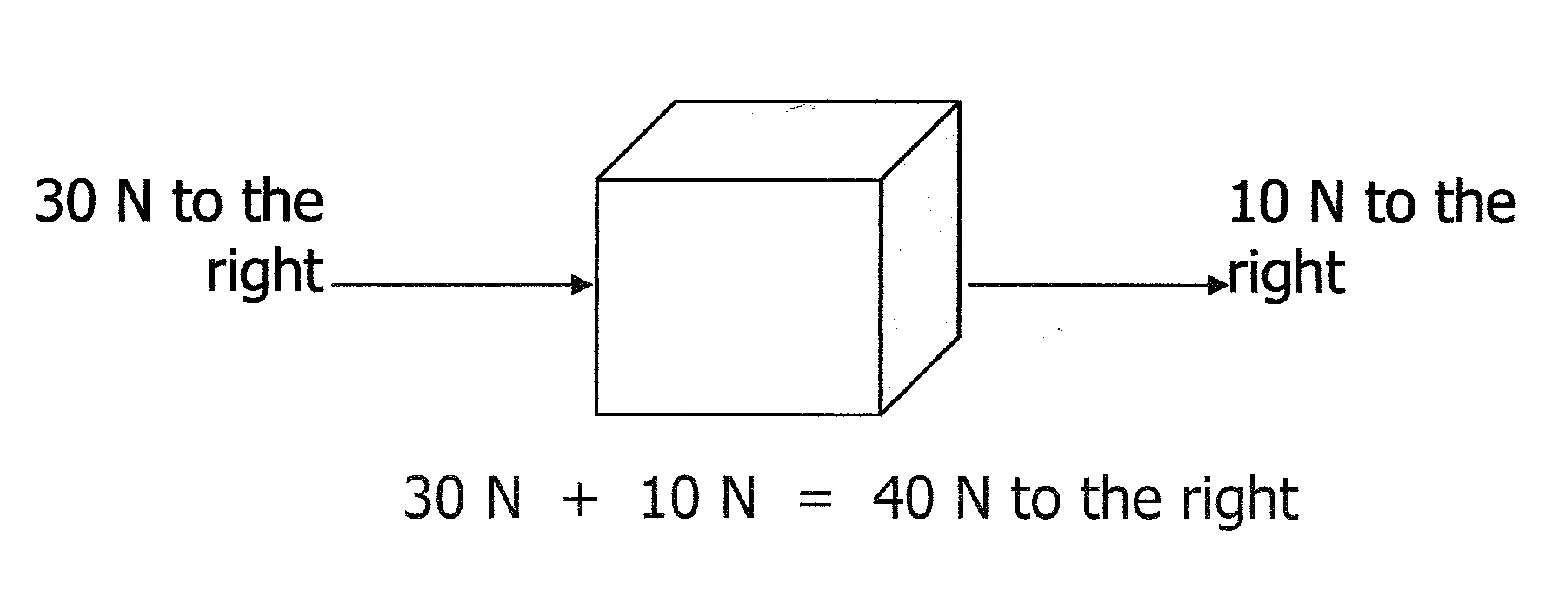
A. 30 N to the right
B. 40 N to the right
C. 10 N to the right
D. 40 N to the left

Thursday Date _____________
Are the forces acting on the box above balanced or unbalanced? Why do you say this is true?

Friday Date ____________
If the upward force on the box
is 200 N are the forces
balanced or unbalanced? Why
do you say this is true?

