Name __________________ period _____
6th Grade Do Now
SCI.6.8D Measure and graph changes in motion.

Monday Date _______________
What are three essential parts to a graph?

Tuesday Date _________________

A golfer collected data on the distance a golf cart traveled in a straight line and plotted it on a graph.
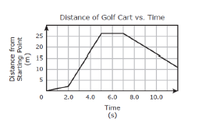
Which of these does NOT describe the cart’s motion on this graph?
A. The cart moved 24 m away from the starting point between 2 s and 5 s.

B. The cart moved toward the starting point at a speed of 3 m/s between 7 s and 12 s.

C. The cart moved 11 m toward the starting point between 8 s and 10 s.

D. The cart moved away from the starting point at a speed of 1 m/s for 2 sec.

Wednesday Date ___________

A hobbyist collected data about the motion of a toy train on a straight track and then recorded the data in the graph below.
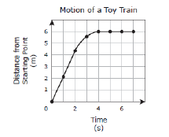
Which of these accurately describes the motion of the toy train?

A. The toy train speeds up while going forward and then slows down.

B. The toy train slows down while going forward and then moves backward.

C. The toy train moves forward at a constant speed, slows down, then stops.

D. The toy train moves forward at an increasing speed, stops and then moves forward.

Thursday Date __________
The graph below shows distance over time.

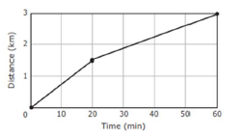
Which of these situations could be represented by this graph?

A. A student walks 1.5 km to a friend’s house in 40 minutes. The two students then walk another 1.5 km to school in 20 minutes.

B. A student walks 1.5 km to a friend’s house in 20 minutes. The two students then walk another 1.5 km to school in 40 minutes.

C. A student walks 1.5 km to a friend’s house in 30 minutes. The two students then walk another 1.5 km to school in 30 minutes.

D. A student walks 1.5 km to a friend’s house in 20 minutes. The two students then walk another 1.5 km to school in 60 minutes.
Friday Date _____________
What is missing on the graph above?



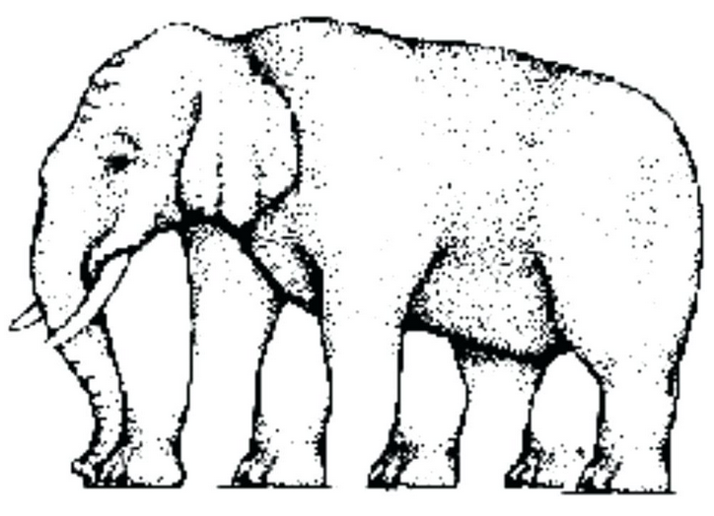
How many legs does this elephant have?

