Name ___________________ period _____
7th Grade DO NOW
7.5C Diagram the flow of energy through living systems including food chains, food webs and energy pyramids.
Monday Date _____________
Match the vocabulary word with its meaning.

_____ 1. Food Web A. Organism that breaks down
wastes into nutrients for the soil

_____2. Food Chain B. An organism that feeds on
other organisms

_____3. Producer C. A diagram that shows the
path of energy as it flows
from one organism to another

_____4. Consumer D. A diagram that shows
interconnected food chains in
an ecosystem

_____5. Decomposer E. Organism that makes its
own food
Tuesday Date ___________
Word | Example
Food Web
Food Chain
Producer
Consumer
Decomposer

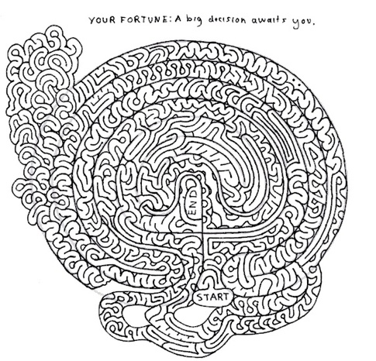

Wednesday Date ________________

Word | NON-Example
Food Web
Food Chain
Producer
Consumer
Decomposer

Thursday Date _______________
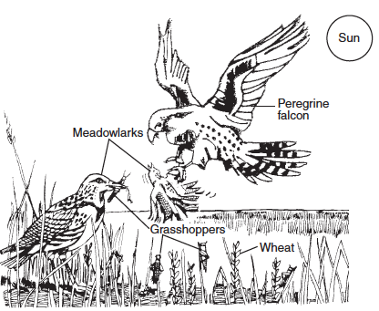
Use the picture to answer the following questions.
1. Give an example of a producer. ________________
2. Give an example of a consumer? _______________
3. From where does the energy for the ecosystem come? ________________________________________________
4. Where are the decomposers? _____________________

Friday Date _______________

Use words to show the food chain found in the picture above. Don’t forget which way the arrows go!

