Name ___________________ period _____
7th Grade DO NOW

7.6A Identify that organic compounds contain carbon
and other elements.
Date _____________
Organic compounds must contain carbon but can also contain hydrogen, oxygen, nitrogen, phosphorous and sulfur. What abbreviation do we use to remember all of these elements?

1. Underline the question.
2. Box the important vocabulary words.
3. Tell something else you know about this topic.
_________________________________________
_________________________________________
4. Answer the question in the space below.

Date ___________
Only certain elements are considered
organic. Circle the elements in the
box that do NOT belong to the organic
elements.

1. Underline the question.
2. Box the important vocabulary words.
3. Tell something else you know about
this topic.
_________________________
________________________
4. Answer the question in the box.

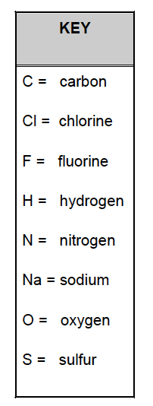

Date ______________
Proteins are chains of carbon. Fats are chains of carbon. Sugar and starch are chains of carbon atoms. Why are these chains of carbon atoms important?
1. Underline the question.

2. Box the important vocabulary words.

3. Tell something else you know about this topic.
_________________________________________
_________________________________________

4. Answer the question in the space below.

Date ________________
Carbon is found as a solid and
a gas on the earth. All living
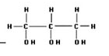
things contain carbon. The
most important quality of
carbon is that it -

1. Underline the question.

2. Box the important vocabulary words.

3. Tell something else you know about this topic.
_________________________________________
_________________________________________

4. Answer the question in the space below.

Date _______________
Why are the following compounds not considered organic?

NaCl H₂O HCl H₂SO₄

1. Underline the question.
2. Box the important vocabulary words.
3. Tell something else you know about this topic.
_________________________________________
_________________________________________

4. Answer the question in the space below.

