Name ___________________ period _____
7th Grade DO NOW

7.6B Distinguish between physical and chemical changes in
matter in the digestive system.
Date _____________
When we place a cracker in our mouth, our teeth break it up into little pieces and our saliva begins to break it down into sugars. Which process is considered a physical change?
1. Underline the question.

2. Box the important vocabulary words.

3. Tell something else you know about this topic.
_________________________________________
_________________________________________
4. Answer the question in the space below.

Date ___________
When we place a cracker in our mouth, our teeth break it up into little pieces and our saliva begins to break it down into sugars. Which process is considered a chemical change?
1. Underline the question.

2. Box the important vocabulary words.

3. Tell something else you know about
this topic.
_________________________
________________________
4. Answer the question in the box.

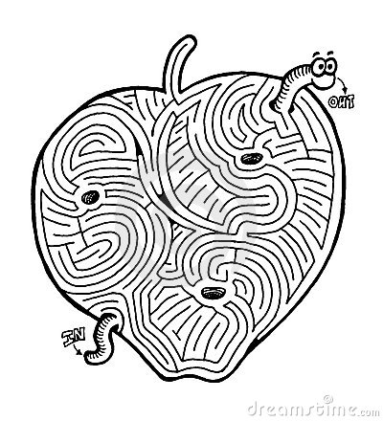

Date ________________
When the food reaches the stomach, the stomach muscles mix it with stomach acid and enzymes. The acid and enzymes begin to break down the food into smaller molecules. Which process is considered a physical change?

1. Underline the question.

2. Box the important vocabulary words.

3. Tell something else you know about this topic.
_________________________________________
_________________________________________

4. Answer the question in the space below.

Date _______________
When the food reaches the stomach, the stomach muscles mix it with stomach acid and enzymes. The acid and enzymes begin to break down the food into smaller molecules. Which process is considered a chemical change?

1. Underline the question.

2. Box the important vocabulary words.

3. Tell something else you know about this topic.
_________________________________________
_________________________________________

4. Answer the question in the space below.

Date _______________
Color the Food Pyramid below.

