Name ___________________ period _____
7th Grade DO NOW

7.7A Contrast situations where work is done with situations
where no work is done.
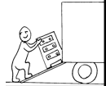
Date _____________
Work is defined as distance moved times force used. Look at the picture and determine if work was done on the dresser when it was moved from the bottom of the ramp to the truck.

1. Underline the question.
2. Box the important vocabulary words.
3. Tell something else you know about this topic.
_________________________________________
_________________________________________
4. Answer the question in the space below.

Date ___________
If the dresser in the picture above weighed 2 times as much, how much more work would be done when moving it from the bottom of the ramp to the truck?

1. Underline the question.
2. Box the important vocabulary words.
3. Tell something else you know about this topic.
__________________________________________
__________________________________________
4. Answer the question in the box.



Date ________________
If the dresser in the picture weighed 5 times as much, how much more work would be done?

1. Underline the question.

2. Box the important vocabulary words.

3. Tell something else you know about this topic.
_________________________________________
_________________________________________

4. Answer the question in the space below.

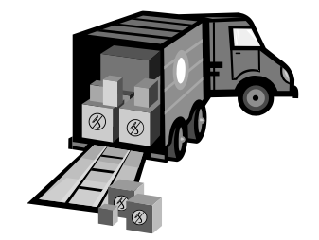
Date _______________
If the boxes in the picture weighed 3 times as much as shown how much
work is being done on the boxes
as they are shown?

1. Underline the question.

2. Box the important vocabulary words.

3. Tell something else you know about this topic.
_________________________________________
_________________________________________

4. Answer the question in the space below.

Date _______________
Explain your answer to yesterday’s question.

1. Underline the question.

2. Box the important vocabulary words.

3. Tell something else you know about this topic.
_________________________________________
_________________________________________

4. Answer the question in the space below.

