Name ___________________ period _____
7th Grade DO NOW

7.7C Demonstrate and illustrate forces that affect motion
in everyday life, such as emergence of seedlings,
turgor pressure, and geotropism.
Date _____________
Match the word with its definition.

_____1. Wilt A. A push or a pull

_____2. Seedling B. What happens to a
plant without enough water

_____3. Turgor Pressure C. To come out of hiding

_____4. Emerge D. What keeps a plant
standing upright

_____5. Force E. Plant that has just
come out of the seed

Date ___________

Part | Plant or Animal?
Seed
Leaf
Blood
Hair
Root

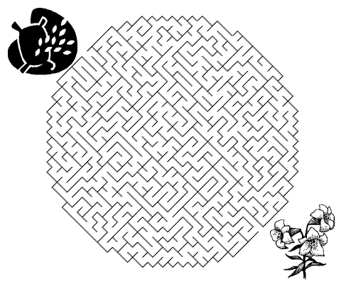

Date ________________
Match the force with its function.

_____1. Gravity A. Allows us to walk without
slipping

_____2. Friction B. Keeps plants upright

_____3. Air Pressure C. Keeps us on the Earth

_____4. Turgor Pressure D. Keeps our underwear up

_____5. Elastic E. Causes winds to blow

Date _______________

Force | Push or Pull?
Gravity
Air Pressure
Friction
Turgor Pressure
Elastic

Date _______________

Vocabulary | Draw It!
Force

Wilt

Turgor Pressure

Emerge

