Name ___________________ period _____
7th Grade DO NOW

SCI.7.10C Observe, record, and describe the role of ecological succession such as in a microhabitat of a garden with weeds.
Date _____________
Match the vocabulary word with its meaning.

_____ 1. Primary Succession A. The first species
to live in an area

_____2. Secondary Succession B. An organism that
can live on bare rock

_____3. Climax Community C. Succession that
occurs in an area where
no communities already
exist

_____4. Pioneer Species D. The final community
of organisms that
results from succession

_____5. Lichen E. Succession that takes
place in an area where
organisms already live
Date ___________

Word | Example
Primary Succession
Secondary Succession
Climax Community
Pioneer Species
Lichen

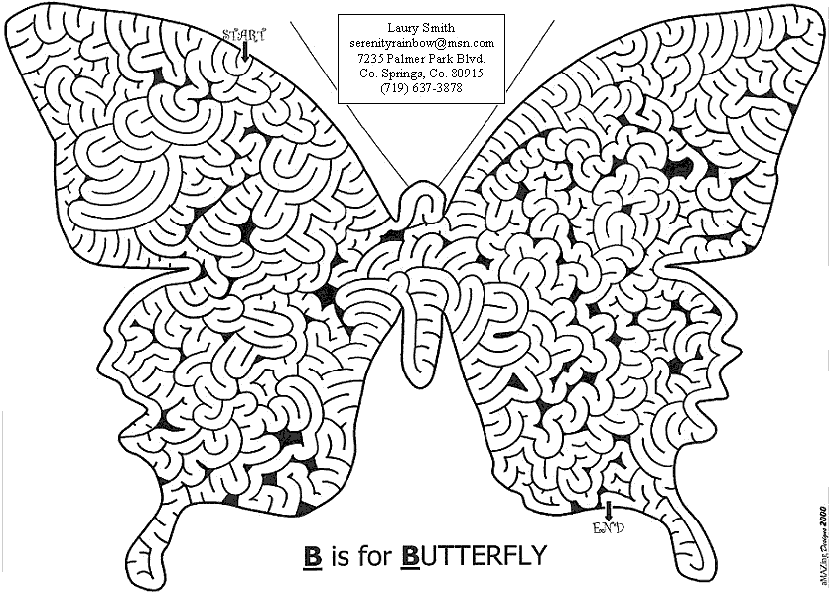

Date ________________

Word | NON-Example
Primary Succession
Secondary Succession
Climax Community
Pioneer Species
Lichen

Date _______________
After a volcanic eruption has covered an area with lava, which of the following is the MOST likely order of succession in the repopulation of the area?

A lichen → grasses → shrubs → trees
B mosses → grasses → lichens → trees
C grasses → trees → mosses → lichens
D shrubs → grasses → trees → lichens

Date _______________

When the Mount St. Helens volcano erupted, the blast covered much of the surrounding area with ash. Based on the diagram above, which list shows the sequence of secondary succession that followed that eruption?

  W, Y, X, Z
  Z, X, Y, W
  Z, Y, W, X
  X, Y, Z, W

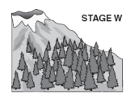 | 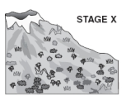
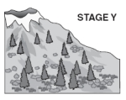 | 