Name ___________________ period _____
7th Grade DO NOW

SCI.7.10B Describe how biodiversity contributes to the sustainability of an ecosystem.
Date _____________
Match the vocabulary word with its meaning.

_____ 1. Biodiversity A. The ability of an ecosystem
to maintain itself in the
face of external stress

_____2. Sustainability B. An area of similar rainfall,
temperatures and elevations

_____3. Ecoregion C. A calculation scientists
use to determine how
healthy and stable a habitat is

_____4. Extinction D. Variety of organisms in a
place

_____5.Biodiversity Index E. The disappearance of an
entire type of organism
Date ___________
Word | Example
Biodiversity
Sustainability
Ecoregion
Extinction
Biodiversity Index



Date ________________

Word | NON-Example
Biodiversity
Sustainability
Ecoregion
Extinction
Biodiversity Index

Date _______________
A biological diverse ecosystem has many different types of plant and animals living in it. How does this contribute to the health of the ecosystem?

A. It allows animals to eat many different kinds of plants and stay healthy.
B. It allows the plants to get more sunlight and grow larger.
C. It allows the ecosystem to survive even if some plants get sick and die.
D. It allows the animals to have many different kinds of places to live.

Date _______________

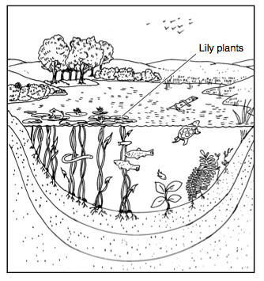
The picture shows a pond ecosystem. What effect would there be if all the lily plants were removed from this community?
_______________________________________________________
______________________________________________________
_____________________________________________________

