Name ___________________ period _____
7th Grade DO NOW

SCI.7.8B Analyze the effects of weathering, erosion, and deposition on the environment in ecoregions of Texas.
Date _____________
Match the vocabulary word with its meaning.

_____ 1. Weathering A. An agent of weathering that
is the result of water combining
with pollution in the atmosphere

_____2. Abrasion B. A type of weathering that is
caused by the growth of plants

_____3. Ice Wedging C. A type of weathering that
can be done by wind, water
or gravity

_____4. Root Pry D. The breaking down of rocks

_____5. Acid Rain E. A type of weathering that is
done by freezing and thawing
Date ___________

Types of Weathering | Caused by?
Oxidation
Abrasion
Dissolving of Rock
Ice Wedging
Root Pry

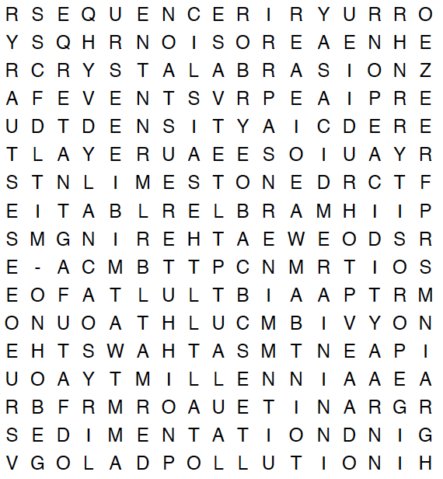
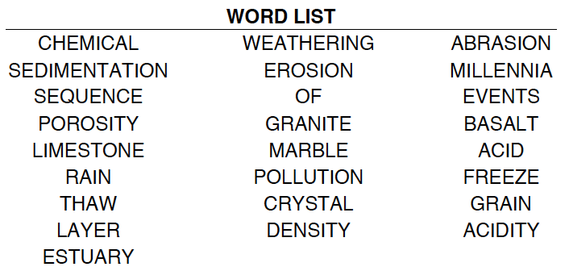

Date ________________
Types of Weathering | Mechanical or Chemical
Oxidation
Abrasion
Dissolving of Rock
Ice Wedging
Root Pry

Date _____________
Match the vocabulary word with its meaning.

_____ 1. Erosion A. Small pieces of material that
have broken off rocks

_____2. Sediment B. Measurement of different
sediments

_____3. Grain size C. A point of high land
jutting into the ocean

_____4. Headlands D. A landform created when a
sea arch fell into the ocean.

_____5.Sea stack E. The movement of weathered
rocks from one place to another
Date ___________

Word | Drawing
Erosion

Sediment

Grain Size

Headlands

Sea Stack



Date ________________

Scrambled Word | Unscrambled Word
LHAAEDDNS
ETCAASSK
SOORIEN
AIIRZEGNS
MDIEENTS

