Name ___________________ period _____
7th Grade DO NOW

SCI.7.8B Analyze the effects of weathering, erosion, and
deposition on the environment in ecoregions of Texas.
Date _______________
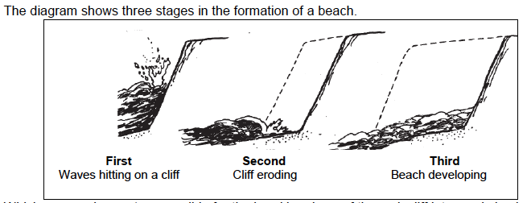
What is the name of all of the weathered and eroded material found on the beach?

A. quartz B. grains C. sediment D. stacks

Date _______________
Match the vocabulary word with its meaning.

_____ 1. Delta A. A series of curves in a river

_____2. Sandbar B. A deep narrow valley
formed by erosion

_____3. Runoff C. An area of deposition found
along a curve in a river

_____4. Meanders D. A fan shaped sediment deposit
formed at the mouth of a river

_____5.Canyon E. Water that flows over land

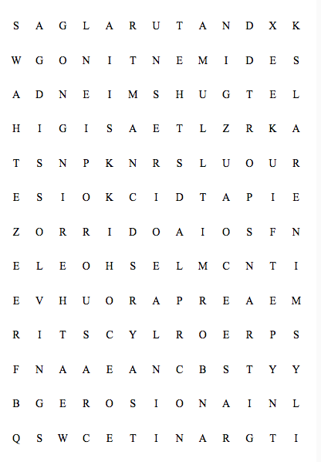
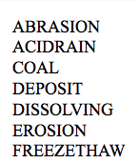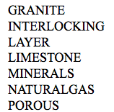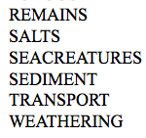

Date _______________
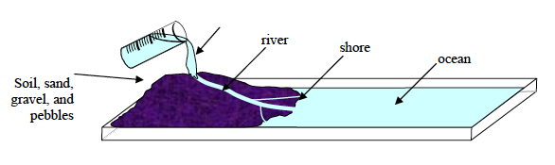

Students use a stream table to model how a river changes the surface of the Earth. When the students finish pouring the water, which change will most likely have taken place?

A. The pebbles will be deposited by the moving water in the location labeled ocean

B. The height of the pile will increase at the top of the hill

C. At the location where the river meets the ocean, sediments will build up forming a delta

D. The pile of sediments will completely flatten out across the ocean

Date _______________

Which of these factors has the least effect on the load of sediment a river can carry?

A. Speed of the river
B. Size of the sediment
C. Color of the sediment
D. Density of the sediment

Date _____________________

What is the dividing line of any high land where runoff runs down one side or the other called?

A. A watershed
B. A runoff
C. A divide
D. A tributary
