Name ___________________ period _____
7th Grade DO NOW

SCI.7.8C Model the effects of human activity on ground water and surface water in a watershed.
Date _____________

Which of the following is NOT an example of surface water?
A. The Mississippi River
B. The Red River
C. The Atlantic Ocean
D. The Evangeline Aquifer

Date ___________

What is an example of point source pollution?

A. A leaking waste disposal site
B. Fertilizer runoff
C. Oil poured down the sewer.
D. Litter

Date ___________

What is an example of nonpoint source pollution?

A. Fertilizer runoff
B. A leaking waste disposal site.
C. A leaking oil pipeline
D. Leaking chemical storage tanks

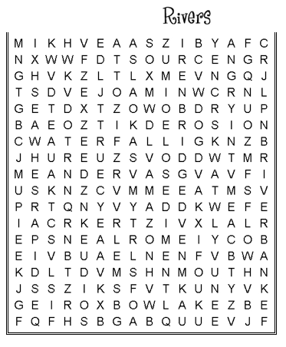
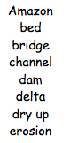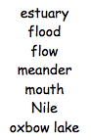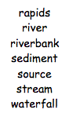

Date _______________

What is the top of the saturated zone called?

A. The water table
B. The aquifer
C. The rock
D. The lake

Date _______________

What is the area that holds a lot of groundwater called?
A. A lake
B. An ocean
C. An aquifer
D. A pond

