Name ___________________ period _____
7th Grade DO NOW

SCI.7.8A Predict and describe how different types of catastrophic events impact ecosystems, such as floods, hurricanes, or tornadoes.

Date _____________

Which of the following is NOT an example of a catastrophic event?

A. A flood
B. A tornado
C. A hurricane
D. A thunderstorm

Date ___________

How do hurricanes impact ecosystems?

A. They cause wind to blow.
B. They cause damage to beaches and coastlines.
C. They cause many forest fires.
D. They cause snowstorms.

Natural Disasters
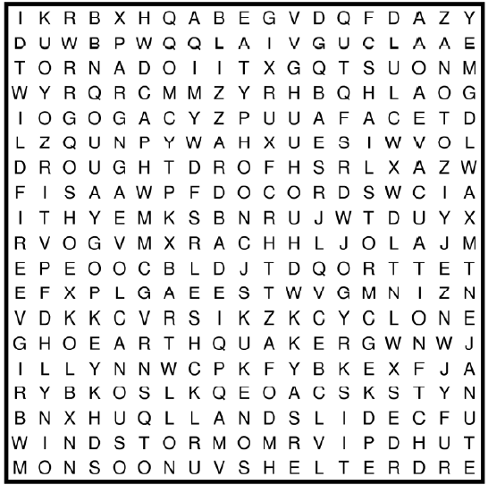
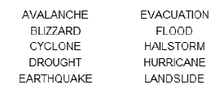
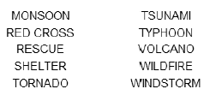

Date ___________

What is a difference between a tornado and a hurricane?

A. Tornados are large and hurricanes are small.
B. Hurricanes are large and tornados are small.
C. Hurricanes cause damage and tornadoes don’t.
D. Tornados cause damage and hurricanes don’t.

Date _______________

Which type of catastrophic event has winds up to 300 mph?

A. A flood
B. A tornado
C. A hurricane
D. A thunderstorm

Date _______________

Describe what an ecosystem might look like after a volcanic eruption.

