Name ___________________ period _____
7th Grade DO NOW

SCI.7.9A Analyze the characteristics of objects in our solar system that allow life to exist such as the proximity of the Sun, presence of water, and composition of the atmosphere.
SCI.7.9B Identify the accommodations, considering the characteristics of our solar system that enabled manned space exploration.

Date _____________

What is the main reason life is found on Earth and not in the rest of the solar system?

A. There is life on other planets.
B. How close we are to the Sun.
C. We have machines to help us live.
D. They don’t have an atmosphere.

Date ___________

What abiotic factors allow life to exist on Earth?

A. Temperature, water and oxygen.
B. Temperature, water and silicon.
C. Temperature, silicon and mud.
D. Temperature, mud and uranium.

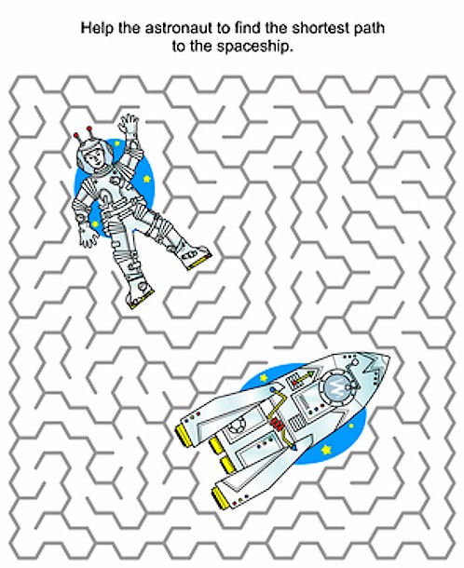

Date ___________

In what forms can water be found on Earth?

A. Solid only
B. Liquid only
C. Gas only
D. Solid, liquid and gas

Date _______________

Why is Earth called a Goldilocks planet?

A. Everyone likes the story of the 3 bears.
B. It’s not too hot and it’s not to cold for life.
C. Everyone wants to have blond hair.
D. The Earth sits between Venus and Mars.

Date _______________

What accommodations must be made for an astronaut to travel into space?

A. An astronaut must have air to breathe and protection from various hazards.
B. An astronaut must have strong hands.
C. An astronaut must be able to go for long periods without eating.
D. An astronaut must be able to go for long periods without breathing.

