Name ___________________ period _____
7th Grade DO NOW
SCI.7.10A Observe and describe how different environments, including microhabitats in schoolyards and biomes, support different varieties of organisms.
Date _____________

In which of the following biomes would you find an elephant?

A. The arctic
B. The Desert
C. The Grassland
D. The Tundra

Date ___________

In which of the following biomes would you find flowering trees?

A. The arctic
B. The tropical rainforest
C. The desert
D. The Tundra

Date _______________________

What microhabitats could be found in the picture below?

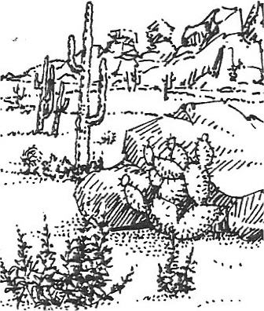

Date ___________

What abiotic factors make the biome pictured in the last question a challenge for living things?

A A lot of sun and very little rain
B. A lot of rain and little sun
C. It is very cold
D. The snow piles up every winter.

Date _______________

What types of microhabitats are found around your school?





