Name ___________________ period _____
7th Grade DO NOW

7.11A Examine organisms and use dichotomous keys for identification
Date _____________

Name three wild animals you will find in the United States.

Date ___________

What tool do scientists use to classify animals?

A. Camera
B. Books
C. Dichotomous Key
D. Computer

Date ______________
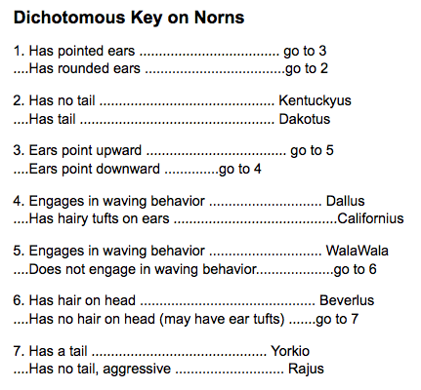
Use the dichotomous key below to find the species of each Norn pictured.

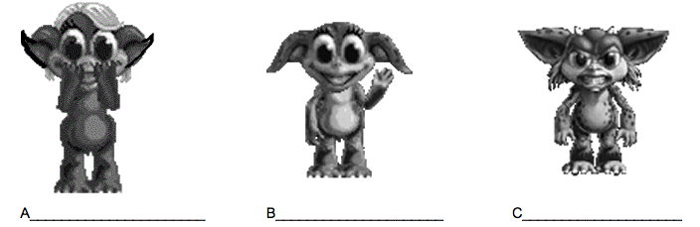
Date __________

What is the process of assigning a scientific name to a plant or animal called?

A. Genetics
B. Taxonomy
C. Dichotomous
D. Classifying

Date _____________

What is the correct way to write a scientific name?

A. First word is lower case.
B. Second word is lower case.
C. Third word is upper case.
D. Fourth word in upper case

