Name ___________________ period _____
7th Grade DO NOW

7.11B Explain variation within a population by comparing external features
Date _____________
Which of the following is considered a population?

A. All the animals at a pet store
B. The ants in an ant hill
C. All the birds that live in a neighborhood
D. The flowers in the park

Date ___________

The differences in a population are called -

Date ____________

Examples of variations are:

A. Eye color
B. Hair length
C. Fingernail length
D. Toe length

Date ______________

How are variations helpful?

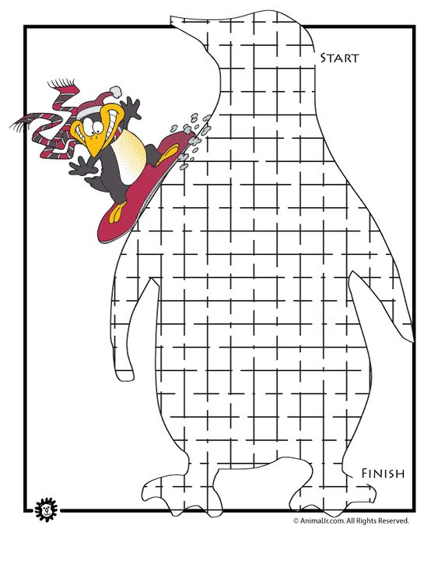

Date ________

Give two examples of behavioral variations.

