Name ___________________ period _____
7th Grade DO NOW

7.11C Identify some changes in genetic traits through natural selection and selective breeding
Date _____________
Until the 19th century, most scientists believed that organisms lived as they had first appeared on the earth. However, by the late 1700’s, scientists had found and studied many fossils. What did the fossils show the scientists?

1. Underline the question.
2. Box the important vocabulary words.
3. Tell something else you know about this topic.
_________________________________________
_________________________________________
4. Answer the question in the space below.

Date ___________
Some farmers grow wheat and corn. Ranchers have herds of cattle used for meat. Dairy farmers have herds of cows that are milked. Some dairy farmers want to increase the amount of milk produced by their cows. How can farmers use selective breeding to increase milk production?

1. Underline the question.
2. Box the important vocabulary words.
3. Tell something else you know about this topic.
_________________________________________
_________________________________________
4. Answer the question in the space below.

Date ______________
When Charles Darwin visited the Galapagos Islands in the 1800s, he observed many types of organisms that were similar but lived on different islands. The Ground Finches are very similar but they have different beaks. Which of the following best explains this difference?

A. One finch needs a longer beak for defense against
predators.

B. Every the finches originated from a different type
of bird that the other finches.

C. One finch’s long beak is an adaptation to the food
available in the bird’s habitat.

D. The finch with the longest beak stretched to reach
its food and passed the longer beak down to its
offspring.

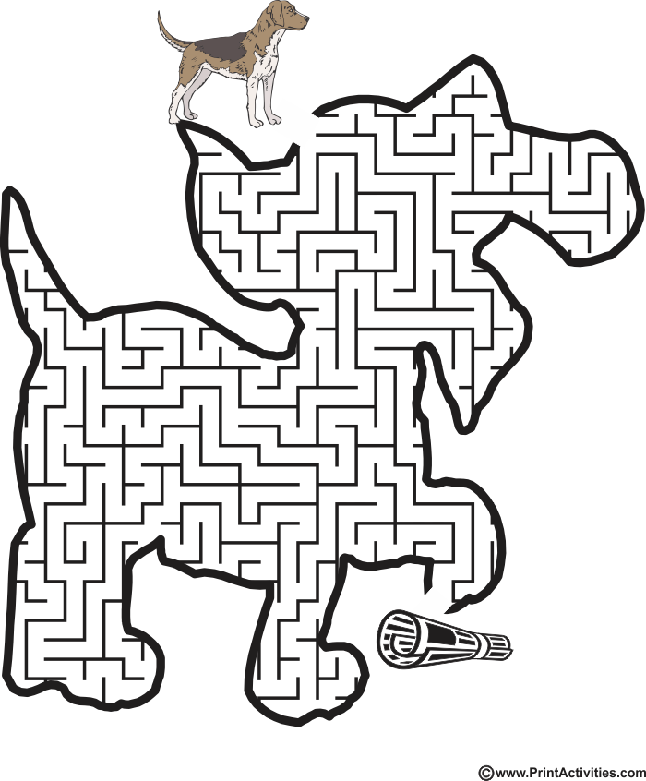

Date ___________

A few years ago the population of male blue buffalo butterflies on the island of Pipsqueak declined. One hypothesis for the decline of the male butterflies is that a parasite infected the cells of female butterflies. The parasite was passed to offspring through the females’ eggs and killed the male butterfly embryos. At one point during the decline, nearly all the butterflies in the population were females, but after five years the number of males in the population increased significantly.

Which explanation most likely accounts for the increase in the number of male butterflies in the five years after the initial parasite problem?
A Male butterflies in the population that survived were able
to prey on the parasites living in the females’ egg cells.

B Female butterflies in the population that survived had a
genetic adaptation that allowed them to transform into
male butterflies.

C Male butterflies in the population that survived had a gene
that made them resistant to the parasite, and they passed the
gene on to their offspring.

D Female butterflies in the population that survived were
able to protect the male eggs from the parasite and provide
extra care for the male offspring.

Date ____________
Name 5 organisms that have been selectively bred by humans.

