Name ___________________ period _____
7th Grade DO NOW

7.12A Investigate and explain how internal structures or organisms
have adaptations that allow specific functions.
Date _____________
A fish’s gills work like lungs in land animals. The fish takes in water through its mouth and forces the water across the gills. What gas is taken out of the water to support the fish?

A. Carbon Dioxide
B. Dissolved Oxygen
C. Neon
D. Hydrogen

Date ___________
Birds have hollow bones Birds also have different shaped beaks. Which of the following is an internal adaptation?

1. Underline the question.
2. Box the important vocabulary words.
3. Tell something else you know about this topic.
_________________________________________
_________________________________________

4. Answer the question in the space below.

Date ______________
A trait that enables an organism to survive and reproduce in its environment is known as an -

A. Habitat
B. Adaptation
C. Structure
D. Internal

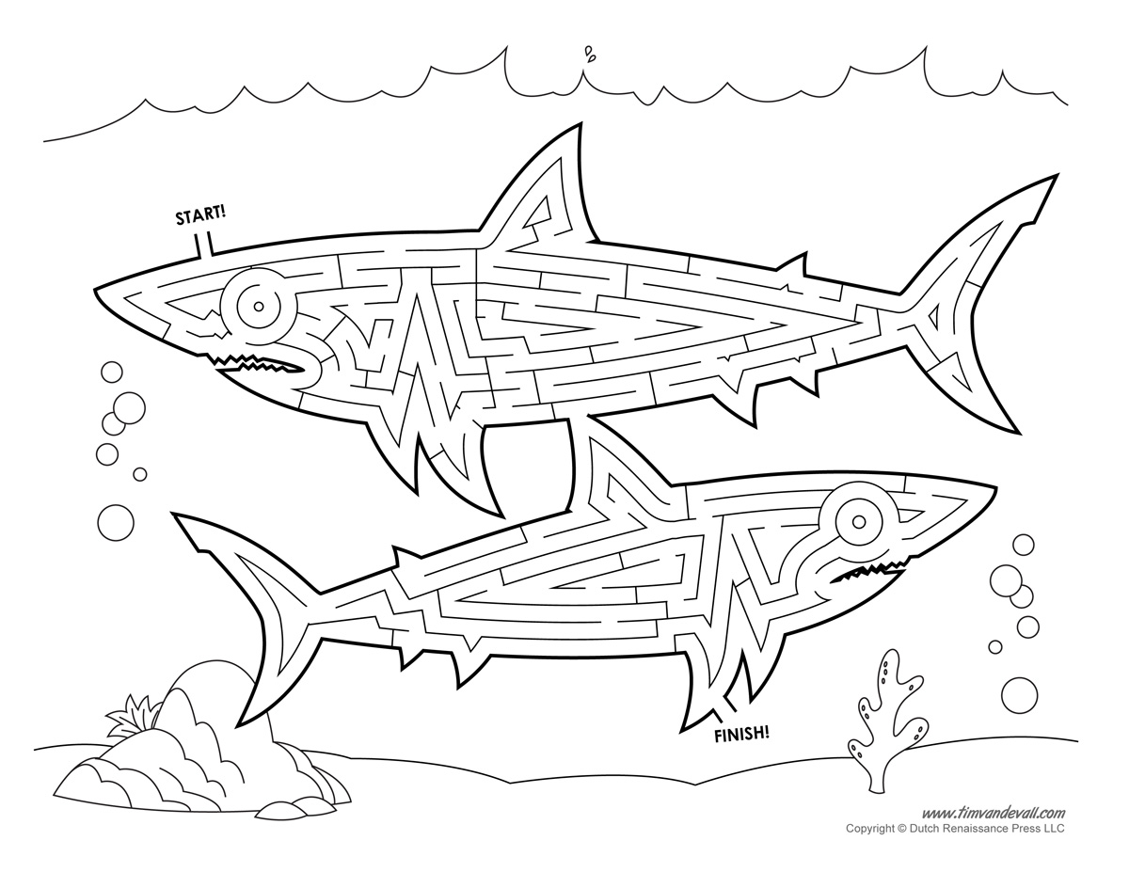

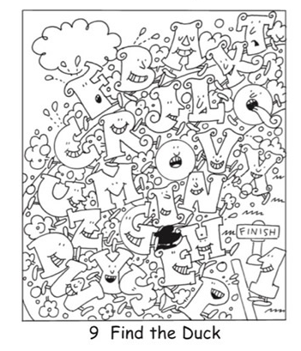

Date ____________
Which of the following is an internal adaptation that
you have?

A. Thumb
B. Lungs
C. Hair
D. Big Toe

Date ____________
Which of the following is an external adaptation that
you have?

A. Thumb
B. Lungs
C. Gills
D. Hollow Bones

