Name ___________________ period _____
7th Grade DO NOW
7.12E Compare the functions of the cell to the function of organism
7.12F Recognize that according to cell theory all organisms are composed of cells
Date _____________
Cells make up tissues and tissues make up organs. Organs make up organ systems and organ systems make up organisms. The function of the nucleus is to direct the cell’s activities. What directs the activities of an organism?
1. Underline the question.
2. Box the important vocabulary words.
3. Tell something else you know about this topic.
_________________________________________
_________________________________________

4. Answer the question in the space below.

Date ___________
All of the organelles in a cell have a specific function to perform. Plant cells have chloroplasts that make the food during photosynthesis. What function does the vacuole perform?
1. Underline the question.
2. Box the important vocabulary words.
3. Tell something else you know about this topic.
_________________________________________
_________________________________________

4. Answer the question in the space below.

Date ______________
The primary function of the cell membrane is to keep the organelles inside the cell. The cytoplasm is the jelly-like material that all the organelles float in. State the primary function of the vacuole.

1. Underline the question.

2. Box the important vocabulary words.

3. Tell something else you know about this topic.
_________________________________________
_________________________________________

4. Answer the question in the space below.

Date ________________

Which of the following is the major idea of the Cell Theory?

A. All living things are made up of cells
B. Some living things come from non-living things
C. No living things have cells

Date _______________

Who of the following list DID NOT contribute ideas to Cell Theory

A. Robert Hooke
B. Albert Einstein
C. Schleiden and Schwann

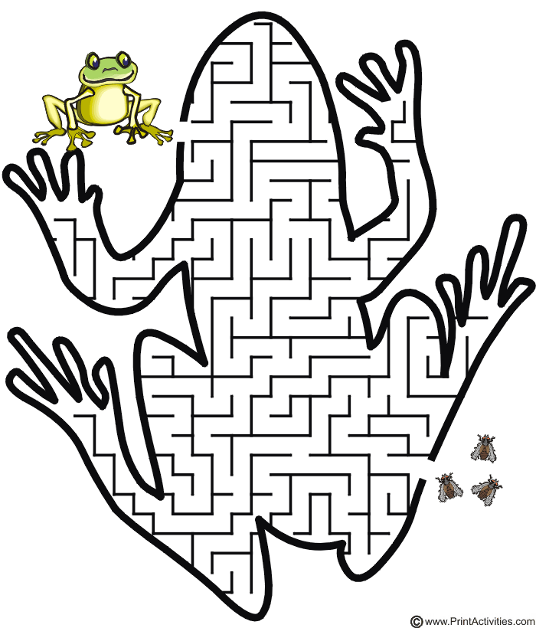

Cell Puzzle

