Name ___________________ period _____
7th Grade DO NOW

7.14A Define heredity as the passage of genetic instructions from one generation to the next generation.
7.14C Recognize that inherited traits of individuals are governed in the genetic material found in the genes within the chromosomes in the nucleus.
Date _____________
The process of passing genetic instructions to offspring is called -

A. Science
B. Biology
C. Heredity
D. Genetics

Date ___________

The shape of a baby’s nose and its hair color are considered -

A. Traits
B. Biology
C. Heredity
D. Genetics

Date ______________
The primary function of the nucleus is the control center of the cell. Inside the nucleus of a human there are 46 chromosomes. Where did the chromosomes come from?

1. Underline the question.
2. Box the important vocabulary words.
3. Tell something else you know about this topic.
_________________________________________
_________________________________________

4. Answer the question in the space below.

Date ________________
The chromosomes found in the nucleus of almost every cell are sometimes shaped like rectangles and sometimes like X’s. What is the main function of these chromosomes?

1. Underline the question.
2. Box the important vocabulary words.
3. Tell something else you know about this topic.
_________________________________________
_________________________________________

4. Answer the question in the space below.

Date _______________

Plant cells have different organelles than animal cells. Which structure in this diagram contains the genetic instructions for the plant?
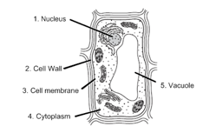

1. Underline the question.

2. Box the important vocabulary words.

3. Tell something else you know about this topic.
_________________________________________
_________________________________________

4. Answer the question in the space below.

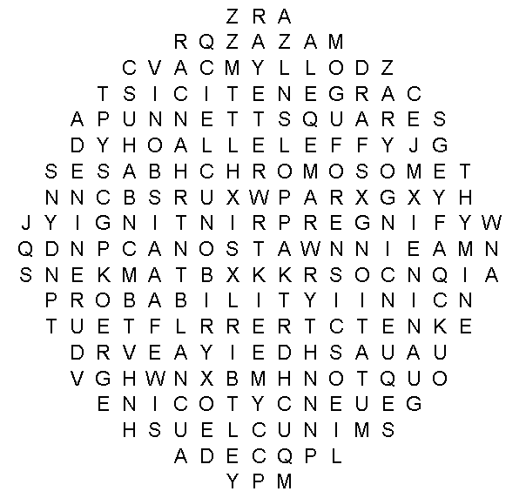
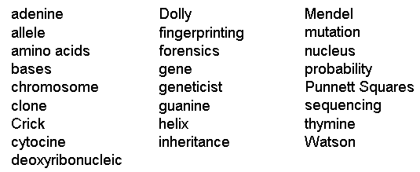
DNA MAZE
