Name ___________________ period _____
7th Grade DO NOW

7.14B Compare the results of uniform or diverse offspring
from sexual and asexual reproduction.
Date _____________
Some species of plants and animals can reproduce both sexually and asexually. The offspring from asexual reproduction are all genetically alike. How can being genetically alike be a disadvantage to the species?

1. Underline the question.
2. Box the important vocabulary words.
3. Tell something else you know about this topic.
_________________________________________
_________________________________________
4. Answer the question in the space below.

Date ___________
When species reproduce sexually the offspring are all different genetically. How can being genetically diverse be an advantage to the species?

1. Underline the question.
2. Box the important vocabulary words.
3. Tell something else you know about this topic.
_________________________________________
_________________________________________
4. Answer the question in the space below.

Date ______________
Species that reproduce sexually have greater variation among the offspring while species that reproduce asexually have less variation among the offspring. What does “greater variation” mean?

1. Underline the question.
2. Box the important vocabulary words.
3. Tell something else you know about this topic.
_________________________________________
_________________________________________

4. Answer the question in the space below.

Date ________________
These organisms are reproducing asexually by budding. What do the new organisms have in common with the original organisms?

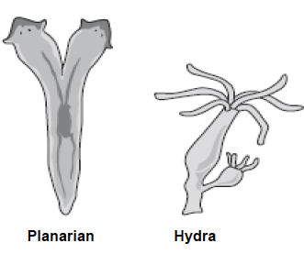
1. Underline the question.
2. Box the important vocabulary words.
3. Tell something else you know about this topic.
_________________________________________
_________________________________________

4. Answer the question in the space below.

Date _______________
Bacteria reproduce asexually through binary fission and yeast reproduce asexually through budding. What percentage of the offspring’s genetic information is the same as the genetic information of the parent?

1. Underline the question.

2. Box the important vocabulary words.

3. Tell something else you know about this topic.
_________________________________________
_________________________________________

4. Answer the question in the space below.

