Name __________________ period _____
6th Grade Do Now
SCI6.10A Build a model to illustrate the structural layers of the Earth including the inner core, outer core, mantle, crust, asthenosphere and lithosphere.
SCI.6.10C Identify the major tectonic plates including Eurasian, African, Indo-Australian, Pacific, North American, and South American.

Monday Date _______________

On what layer of the earth do we live?

A. Core
B. Mantle
C. Asthenosphere
D. Crust

Tuesday Date _________________

How would you describe the Inner Core of the Earth?

A. It is solid and made of iron.
B. It is molten and made of iron and nickel.
C. It is a semisolid and made of iron and magnesium.
D. It is solid and made of oxygen and silicon.

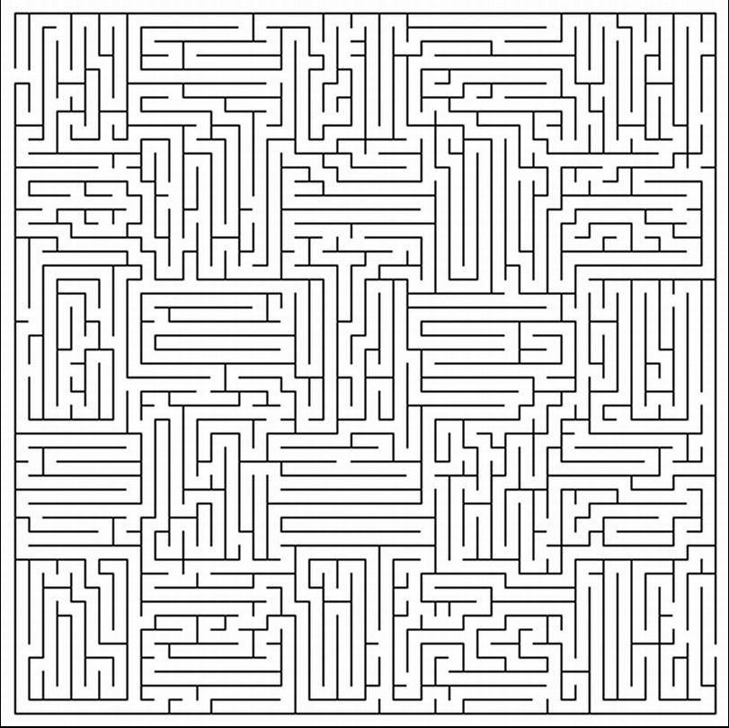

Which grey circle is larger?



Wednesday Date __________
What theory do scientists used to explain the moving continents?

A. Evolution Theory
B. Plate Tectonic Theory
C. Cell Theory
D. Gravitational Theory

Thursday Date __________

Name two tectonic plates.

Friday Date ___________

What scientist proposed the idea of Continental Drift?

A. Charles Darwin
B. Albert Einstein
C. Bill Nye
D. Alfred Wegener

Shade in all the listed items below.

