Name __________________ period _____
6th Grade Do Now
SCI.6.10D Describe how plate tectonics causes major geological events, such as ocean basins, earthquakes, volcanic eruptions, and mountain building

Monday Date _______________

What evidence do scientists have that supports the Theory of Plate Tectonics?

Tuesday Date _________________

What causes the continents to move?

A. The ocean waves
B. The pull of the moon
C. Convection Currents
D. They don’t move

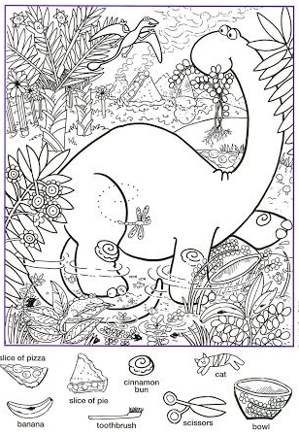
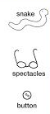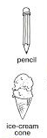
Wednesday Date _________

What type of plate boundary causes ocean basins?

A. Divergent boundary
B. Convergent boundary
C. Transform boundary
D. Preform Boundary

Thursday Date ____________

What type of plate boundary causes volcanoes?

A. Divergent boundary
B. Convergent boundary
C. Transform boundary
D. Preform Boundary

Friday Date ___________

What type of plate boundary happens when two plates slide side by side?

A. Divergent boundary
B. Convergent boundary
C. Transform boundary
D. Preform Boundary

