6th grade Unit 2– Classifying Matter and Metals, Nonmetals and Metalloids

HISD Objectives

SCI.6.1A Demonstrate safe practices during laboratory investigations as outlined in the Texas Safety Standards
SCI.6.2C Collect and record data using the International System of Units (SI) and qualitative means such as labeled drawings, writing and graphic organizers.
SCI.6.4A Use appropriate tools to collect, record and analyze information
SCI.6.5A Know that an element is a pure substance represented by chemical symbols.
SCI.6.5B Recognize that a limited number of the many known elements comprise the largest portion of solid Earth, living matter, oceans, and the atmosphere.
SCI.6.5C Differentiate between elements and compounds on the most basic level.
SCI.6.5D Identify the formation of a new substance by using evidence of a possible chemical change such as the production of a gas, change in temperature, production of a precipitate or color change.
SCI.6.6A Compare metals, nonmetals and metalloids using physical properties such as luster, conductivity or malleability.

Activity 1 Introduction to the Periodic Table
Materials: Copy of periodic table, colored pencils

Focus: I can identify elements found on the periodic table by their group and period.
SIOP Language Objective: I can gather information about elements by reading the periodic table.

Make a foldable to glue in the notebook. Glue only on the anchor tabs.

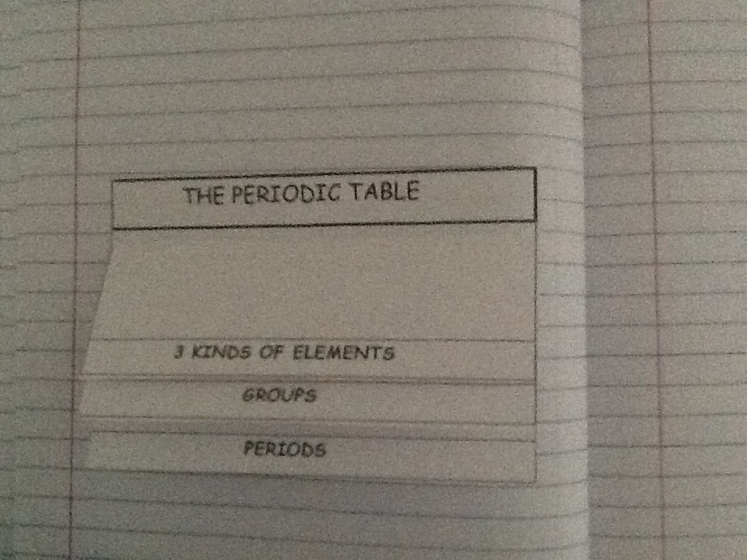
Anchor Tab

Activity 2 Metals and Nonmetals
Materials: Demonstration – mirror, cookie, ball of clay
Materials for each lab table: Periodic Table, carbon (charcoal briquette), iron
washer, lead, sulfur, copper, aluminum, magnet, conductivity tester
Meet the Elements video – google and download the one found on http://boingboing.net

Focus: I can identify elements as metals and nonmetals.
SIOP Language Objective: I can listen and watch a video and identify different elements
mentioned.

Activity 3 Combining Elements
Materials: Scissors, glue, elements sheet, periodic table

Focus: I can identify that elements combine to make compounds.
SIOP Language Objective: I can work with my partner to use TAILS to make an
excellent graph.

Activity 4 Pure Substances
Materials: Teacher Demo baking soda, Damp Rid, 2 -250 mL beakers with 50 mL of water, small spoon

Focus: I can know that an element is a pure substance represented by chemical symbols
SIOP Language Objective: I can work with a partner to complete a concept map that classifies pure substances into elements and compounds.

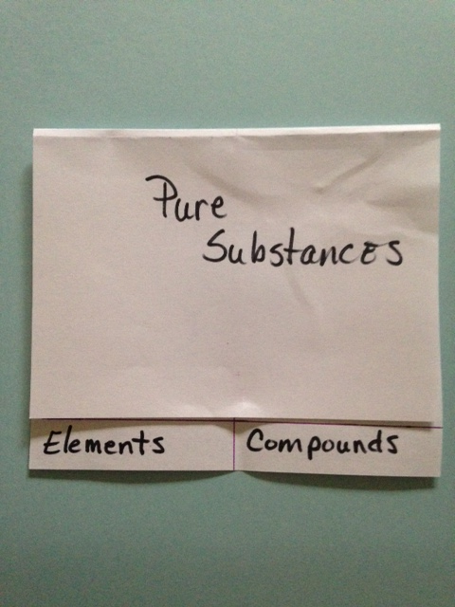
Glue in the notebook.

Activity 5 The Difference between Elements and Compounds
Materials: Periodic Table, Element/Compound Cards

Focus: I can use my knowledge of elements and compounds to write the chemical formulas of compounds.
SIOP Language Objective: I can work with my partner to determine is a substance is an element or a compound

