The Difference Between

Elements and Compounds
You have learned how to write the symbols for the elements. You have also learned to write symbols for a compound, which is called a formula. Remember that if there is only one element in the compound there is no subscript written. If there is more than one atom in the molecule a subscript number is placed after the element in the formula.

Directions: In the activity below you will write the chemical formula for each compound using the element symbols and the subscript numbers. Use the periodic table.

1. Rust is also called iron oxide. It has two parts iron and three parts oxygen.

Write the formula for iron oxide _________________
How many elements are in this compound? _____

2. Baking soda has one part sodium, one part hydrogen, one part carbon and three parts oxygen.

Write the formula for baking soda ________________
How many elements make up this compound?_____

3. Glucose is a type of sugar we find in plants. It has six parts carbon, twelve parts hydrogen and six parts oxygen.

Write the formula for glucose ___________________
How many elements are in this compound? _____

4. Carbon monoxide is a very deadly gas that is made by cars. It has one part carbon and one part oxygen.

Write the formula for carbon monoxide __________
How many elements are in this compound?_____

5. Methane is a gas that is made in the human body. It has one part carbon and four parts hydrogen.

Write the formula for methane _________________
How many elements are in this compound?_____

6. Sand is made up of tiny crystals of silicon dioxide. It has one part silicon and two parts oxygen.

Write the formula for silicon dioxide _____________
How many elements are in this compound? ______

7. Hydrogen peroxide is used to clean cuts without stinging. It has two parts hydrogen and two parts oxygen.

Write the formula for hydrogen peroxide _________
How many elements are in this compound? ______

Questions:
1. How many elements of carbon are in CO₂? __________
2. How do you know? ___________________________
3. How many elements make up CO₂? ______________
4. How do you know? ___________________________

Materials: Element/Compound Cards
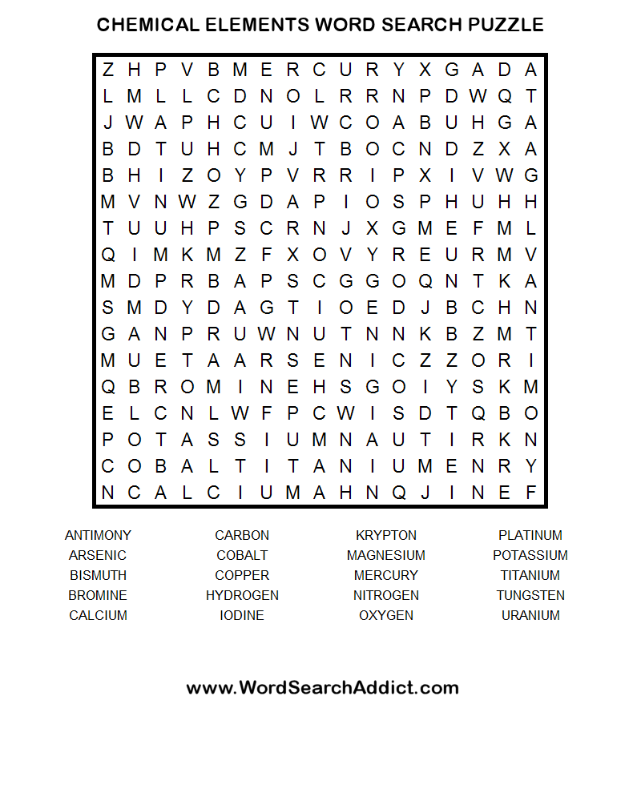
Directions: Look at the cards in the basket with your partner. Determine if the substance on each card is an element or a compound. Write the information in the chart below.

Name | Copy the Symbol or Formula | Is it an Element  or a Compound | Is it a pure substance?  (Yes or No)

Questions:
1. How did you determine if the substance on the card was an element or a compound? ___________________________
____________________________________________

2. Which substances are pure substances? ______________

3. Which substances are not pure substances? ___________

Name ___________________ period ____

EXIT TICKET
The Difference Between Elements and Compounds

Directions: In the chart below determine if the substance is an element or compound and if it is a pure substance or not.

Substance | Element  or Compound? | Pure substance?  Yes/No
H
H₂O
CO₂
C
O
O₂

Conclusion: (elements, one, capital, compound, pure)

A ________ is a substance made up of more than _____ type of element. __________and compounds are considered _________ substances. One way to tell if a substance is a compound is to look for more than one __________letter.

Name ___________________ period ____

EXIT TICKET
The Difference Between Elements and Compounds

Directions: In the chart below determine if the substance is an element or compound and if it is a pure substance or not.

Substance | Element  or Compound? | Pure substance?  Yes/No
H
H₂O
CO₂
C
O
O₂

Conclusion: (elements, one, capital, compound, pure)

A ________ is a substance made up of more than _____ type of element. __________and compounds are considered _________ substances. One way to tell if a substance is a compound is to look for more than one __________letter.

